Increasing post-digestive solubility of curcumin is the most successful strategy to improve its oral bioavailability: a randomized cross-over trial in healthy adults and in vitro bioaccessibility experiments

Supporting information
Enrollment (n = 12; 6 females, 6 males)
Intervention 1 (n = 12)
Intervention 2 (n = 12)
Intervention 3 (n = 12)
Intervention 4 (n = 12)
Intervention 5 (n = 12)
Intervention 6 (n = 12)
Intervention 7 (n = 12)
Intervention 8 (n = 12)
≥ 1 week washout
≥ 1 week washout
≥ 1 week washout
≥ 1 week washout
≥ 1 week washout
≥ 1 week washout
≥ 1 week washout
≥ 1 week washout

Figure S1. Study CONSORT flow chart diagram. In random order, each participant received one of the eight curcumin formulations on each intervention day. CONSORT, Consolidated Standards of Reporting Trials.
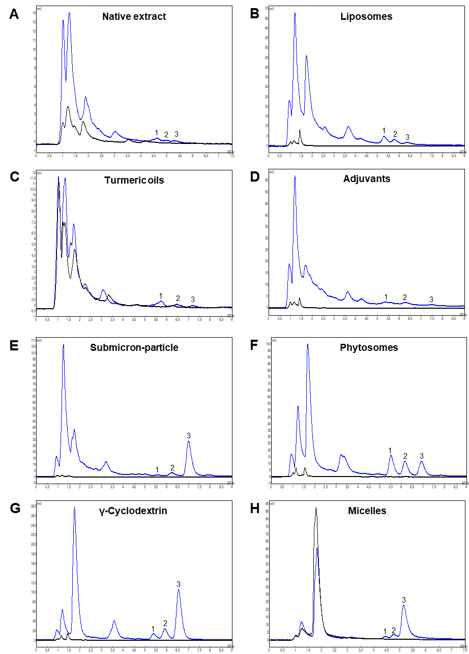
Figure S2. Exemplary HPLC chromatograms of the analyzed plasma samples 2 h after oral administration of 207 mg curcumin in form of (A) native extract, (B) liposomes, (C) turmeric oils, (D) adjuvants, (E) submicron-particle curcumin, (F) phytosomes, (G) γ-cyclodextrin complex and (H) micelles with (blue) or without (black) prior treatment with β-glucuronidase. Peak 1, bis-demethoxycurcumin; peak 2, demethoxycurcumin; peak 3, curcumin.

Figure S3. Scatter dot plots of total plasma curcumin AUC_{0-24 h} following the intake of 207 mg curcumin from each of the given formulations in the study population (n = 12). (A) shows formulations with lower and (B) with higher bioavailability. Data from individual participants are presented in the same colour in all plots. Horizontal black lines present the mean AUC_{0-24 h} for each formulation (n = 12). AUC, area under the plasma concentration time curve.

Table S1. Data reported in previous clinical trials that was used to calculate “dose-normalized” pharmacokinetic data (AUC_{0-24 h}, C_{max}) for total (free plus conjugated) curcumin displayed in Figure 1.^{a)}
Formulation | Dose  [mg] | AUC  [nM x h] | AUC/dose  [(nM x h) mg⁻¹] | C_{max}  [nM] | C_{max}/dose, [nM mg⁻¹] | Reference
Native extract | 30 | 11.13 | 0.37 | 4.89 | 0.16 | ^{[1]}
Native extract | 80 | 6.50 | 0.08 | 0.60 | 0.01 | ^{[2]}
Native extract | 323 | 11.29 | 0.03 | 3.31 | 0.01 | ^{[3]b)}
Native extract | 410 | 65.60 | 0.16 | 7.10 | 0.02 | ^{[4]}
Native extract | 1295 | 332.54 | 0.26 | 24.43 | 0.02 | ^{[5]}
Native extract | 1350 | 29.32 | 0.02 | 6.24 | 0.01 | ^{[6]c)}
Native extract | 1774 | 53.48 | 0.03 | 6.24 | < 0.01 | ^{[7]}
Native extract | 2920 | 1985.99 | 0.68 | 154.73 | 0.05 | ^{[8]}
Polysorbate 80 micelles | 80 | 574.40 | 7.18 | 129.70 | 1.62 | ^{[2]}
Polysorbate 80 micelles | 410 | 12147.70 | 29.63 | 3228.00 | 7.87 | ^{[4]}
γ-Cyclodextrin complex | 348 | 889.57 | 2.56 | 198.71 | 0.57 | ^{[7]}
Phytosomes | 152 |  |  | 159.62 | 1.05 | ^{[9]}
Phytosomes | 165 | 740.00 | 4.48 | 65.69 | 0.40 | ^{[5]}
Phytosomes | 282 | 77.91 | 0.28 | 7.6 | 0.03 | ^{[6]}
Phytosomes | 297 | 1460.45 | 4.92 | 136.54 | 0.46 | ^{[5]}
Phytosomes | 303 | 1817.15 | 6.00 | 192.74 | 0.64 | ^{[8]}
Phytosomes | 354 | 95.28 | 0.27 | 12.76 | 0.04 | ^{[7]}
Turmeric oils | 279 |  |  | 122.16 | 0.44 | ^{[9]}
Turmeric oils | 282 | 15.74 | 0.06 | 1.36 | <0.01 | ^{[6]c)}
Turmeric oils | 355 | 18.19 | 0.05 | 2.44 | 0.01 | ^{[7]}
Submicron-particle | 30 | 306.75 | 10.22 | 80.08 | 2.67 | ^{[1]}
Submicron-particle | 150 | 7190.94 | 47.94 | 513.06 | 3.42 | ^{[10]}
Submicron-particle | 210 | 9905.53 | 47.17 | 746.51 | 3.55 | ^{[10]}
Submicron-particle | 182 | 1881.21 | 10.34 | 779.62 | 4.283 | ^{[9]}
^{a)} All data describe the reported means. AUC, area under the plasma concentration time curve; C_{max}, maximum plasma concentration
^{b)} AUC_{0-48 h} is reported
^{c)} AUC_{0-12 h} is reported, curcumin dose is calculated based on the reported dose of total curcuminoids
Table S2. Data reported in previous clinical trials that was used to calculate “dose-normalized” pharmacokinetic data (AUC_{0-24 h}, C_{max}) for free curcumin displayed in Figure 1.^{a)}
Formulation | Dose  [mg] | AUC  [nM x h] | AUC/dose  [(nM x h) mg⁻¹] |  | C_{max}  [nM] | C_{max}/dose, [nM mg⁻¹] | Reference
Native extract | 1500 | 1253.87 | 0.84 | 406.65 |  | 0.27 | ^{[11]}
Native extract | 1500 | 10.86 | 0.01 | 16.29 |  | 0.01 | ^{[12]b)}
Native extract | 323 |  |  | 0.81 |  | < 0.01 | ^{[3]}
Native extract | 1140 | 151.47 | 0.13 | 48.86 |  | 0.04 | ^{[13]}
Polysorbate 80 micelles | 50 | 68.4 | 1.36 | 24.7 |  | 0.49 | ^{[13]}
Phytosomes | 146 | 102.07 | 0.70 | 30.67 |  | 13.77 | ^{[13]}
Liposomes | 163 | 258.60 | 1.59 | 60.81 |  | 0.37 | ^{[14]c)}
Liposomes | 500 | 417.94 | 0.84 | 88.25 |  | 0.18 | ^{[14]c)}
Liposomes | 750 | 554.75 | 0.74 | 85.29 |  | 0.11 | ^{[14]c)}
Liposomes | 1000 | 735.00 | 0.74 | 111.71 |  | 0.11 | ^{[14]c)}
Native extract + piperine | 1120 | 146.86 | 0.13 | 35.02 |  | 0.03 | ^{[13]}
Native extract + piperine | 1500 | 217.17 | 0.14 | 488.63 |  | 0.33 | ^{[12]b)}
Turmeric oils | 1500 | 8690.21 | 5.79 | 1240.30 |  | 0.83 | ^{[11]}
^{a)} All data describe the reported means. AUC, area under the plasma concentration time curve; C_{max}, maximum plasma concentration
^{b)}AUC_{0-3 h} is reported, curcumin dose is calculated based on the reported dose of total curcuminoids
^{c)} AUC_{0-12 h} is reported, curcumin dose is calculated based on the reported dose of total curcuminoids

Table S3. Doses of curcumin, demethoxycurcumin, bis-demethoxycurcumin, and microcrystalline cellulose (all in mg) administered with each of the eight formulations in the clinical trial and ingredients as declared by the manufacturers.
Formulation | Curcumin | Demethoxycurcumin | Bis-demethoxycurcumin | Cellulose | Ingredients
Native extract | 207.00 | 52.38 | 8.82 | 1628.40 | Curcuma longa extract
Liposomes | 207.00 | 45.60 | 4.86 | 900.00 | Curcuma longa extract, soy lecithin, stearic acid,maltodextrin, ascorbyl palmitate, silicon dioxide
Turmeric oils | 207.00 | 49.32 | 6.78 | 1628.40 | Turmeric rhizome extract
Adjuvants | 207.00 | 29.98 | 2.61 | 1020.00 | Agaricus blazei Murill, curcuma extract, powdered oak bark, L-carnitine, micronized curcuma extract, molybdenum, quercetin, black pepper extract, grape seed extract
Submicron-particle | 207.00 | 25.86 | 5.22 | 1200.00 | Turmeric oleoresin curcumin, starch sodium octenyl succinate, citric acid, maltodextrin, maltose
Phytosomes | 207.00 | 16.20 | 1.56 | 450.00 | Curcuma longa extract, phospholipid complex from sunflower
γ-Cyclodextrin | 207.00 | 47.22 | 6.24 | 120.00 | Curcuminoids, γ-cyclodextrin
Micelles | 207.00 | 48.36 | 7.02 | 0.00 | Polysorbate 80, curcuma oleoresin

References of Supporting Information
[1] H. Sasaki, Y. Sunagawa, K. Takahashi, A. Imaizumi, H. Fukuda, T. Hashimoto, H. Wada, Y. Katanasaka, H. Kakeya, M. Fujita et al., Biol. Pharm. Bull., DOI: 10.1248/bpb.34.660.
[2] A. Kocher, C. Schiborr, D. Behnam, J. Frank, Journal of Functional Foods, DOI: 10.1016/j.jff.2015.01.045.
[3] S. J. Stohs, J. Ji, L. R. Bucci, H. G. Preuss, J. Am. Coll. Nutr., DOI: 10.1080/07315724.2017.1358118.
[4] C. Schiborr, A. Kocher, D. Behnam, J. Jandasek, S. Toelstede, J. Frank, Mol. Nutr. Food Res., DOI: 10.1002/mnfr.201300724.
[5] J. Cuomo, G. Appendino, A. S. Dern, E. Schneider, T. P. McKinnon, M. J. Brown, S. Togni, B. M. Dixon, J. Nat. Prod., DOI: 10.1021/np1007262.
[6] R. Jäger, R. P. Lowery, A. V. Calvanese, J. M. Joy, M. Purpura, J. M. Wilson, Nutr. J., DOI: 10.1186/1475-2891-13-11.
[7] M. Purpura, R. P. Lowery, J. M. Wilson, H. Mannan, G. Münch, V. Razmovski-Naumovski, Eur. J. Nutr., DOI: 10.1007/s00394-016-1376-9.
[8] G. N. Asher, Y. Xie, R. Moaddel, M. Sanghvi, K. S. S. Dossou, A. D. M. Kashuba, R. S. Sandler, R. L. Hawke, J. Clin. Pharmacol., DOI: 10.1002/jcph.806.
[9] Y. Sunagawa, S. Hirano, Y. Katanasaka, Y. Miyazaki, M. Funamoto, N. Okamura, Y. Hojo, H. Suzuki, O. Doi, T. Yokoji et al., J. Nutr. Sci. Vitaminol., DOI: 10.3177/jnsv.61.37.
[10] M. Kanai, A. Imaizumi, Y. Otsuka, H. Sasaki, M. Hashiguchi, K. Tsujiko, S. Matsumoto, H. Ishiguro, T. Chiba, Cancer Chemother. Pharmacol., DOI: 10.1007/s00280-011-1673-1.
[11] B. Antony, B. Merina, V. S. Iyer, N. Judy, K. Lennertz, S. Joyal, Indian J. Pharm. Sci., DOI: 10.4103/0250-474X.44591.
[12] G. Shoba, D. Joy, T. Joseph, M. Majeed, R. Rajendran, P. S. Srinivas, Planta Med., DOI: 10.1055/s-2006-957450.
[13] P. Fança-Berthon, M. Tenon, S. Le Bouter-Banon, A. Manfré, C. Maudet, A. Dion, H. Chevallier, J. Laval, R. B. van Breemen, J. Nutr., DOI: 10.1093/jn/nxab087.
[14] V. S. Gota, G. B. Maru, T. G. Soni, T. R. Gandhi, N. Kochar, M. G. Agarwal, J. Agric. Food Chem., DOI: 10.1021/jf9024807.

