Mapping rust resistance in European winter wheat: Many QTLs for yellow rust, but only a few well characterized loci in stem rust

Thomas Miedaner, Wera Eckhoff, Kerstin Flath, Anne-Kristin Schmitt, Philipp Schulz, Johannes Schacht, Philipp Boeven, Wessam Akel, Hubert Kempf, Paul Gruner

Supplementary files

Table S1 Phenotyping of Pop1-Pop7 for yellow rust (YR) and stem rust (SR)
Pop |  | 2020 |  |  |  |  | 2021
 |  | DAH | HOH | LEM | ROS |  | DAH | HOH | LEM | ROS | SOL
Pop1 |  | YR/SR | YR/SR | YR |  |  | YR | YR/SR | YR
Pop2-4 |  |  | YR/SR |  | YR |  |  | YR/SR |  | YR/SR
Pop5-7 |  |  |  |  |  |  | YR/SR | YR/SR |  |  | YR/SR
DAH=Berlin-Dahlem, HOH=Stuttgart-Hohenheim, LEM=Lemgo, ROS=Rosenthal-Peine, SOL=Söllingen

Table S2 Origin, denomination, virulence and genetic cluster of the isolates of Puccinia graminis f. sp. tritici (Pgt), Puccinia striiformis (Pst) that were used for inoculation of field trials
Patho-gen | Material | Genetic group | Race | Isolate ID |  | Origin  location  (Federal State¹⁾) | Sam-pling year | Virulences
 |  |  |  | Lab | Reference
Pgt | Pop1 (2020) | Clade VIII | HFCLB | WSR-55/13-8 | WSR-55/13-8²⁾ | Söllingen (NI) | 2013 | Sr5, 21, 7b, 8a, 9g, 17, 9a, 10, McN
Pgt | Pop1 (2021) | Clade IV-A.1 | TKTTF | WSR-B5/19-2 | DE09_21²⁾ | Silstedt (SA), (Barberry) | 2019 | Sr5, 6, 7b, 8a, 9a, 9b, 9d, 9e, 9g, 10, 17, 21, 30, 36, 38, Tmp, McN
Pgt | Pop2-Pop4 | Clade VIII | HFCLB | WSR-55/13-8 | WSR-55/13-8²⁾ | Söllingen (NI) | 2013 | Sr5, 21, 7b, 8a, 9g, 17, 9a, 10, McN
Pgt | Pop5-Pop7 | Clade IV-A.1 | TKTTF | WSR-B5/19-2 | DE09_21²⁾ | Silstedt (SA), (Barberry) | 2019 | Sr5, 6, 7b, 8a, 9a, 9b, 9d, 9e, 9g, 10, 17, 21, 30, 36, 38, Tmp, McN
Pst | Pop1 | PstS7 | Warrior | GR-11/19 | DE2019Kl_YR2²⁾³⁾ | Denzlingen (BW) | 2019 | Yr1, 2, 3, 4, 6, 7, 9, 17, 25, 32, Sp, AvS, Amb
Pst | Pop2-Pop4 | PstS10 | Benchmark | GR-217/16 | ³⁾ | Granskevitz (MV) | 2016 | Yr1, 2, 3, 4, 6, 7, 9, 17, 25, 27, 32, Sp, AvS, Amb
Pst | Pop5-Pop7 | PstS7 | Warrior | GR-166/16 | ³⁾ | Dornburg (TH) | 2016 | Yr1, 2, 3, 4, 6, 7, 8, 9, 17, 25, 27, 32, Sp, AvS, Amb
¹⁾ Federal state: SA = Saxony-Anhalt, TH = Thuringia, NI = Lower Saxony, MV = Mecklenburg-Western Pomerania, BW = Baden-Wuerttemberg
²⁾ Tested by GRRC, Global Rust Reference Center, Aarhus University, Denmark
³ ⁾ Tested by Julius Kühn-Institute, Kleinmachnow, Germany

Table S3 Mean, minimum and maximum of stem rust severity (%), heritabilities (H²) and Repeatabilities (Rep.) across environments (env.) and at the single locations, respectively (BLUEs, backtransformed)
Pop | Env. | Mean | Minimum | Maximum | H²/Rep.
Pop1 | Across env. | 2.9 | 0.5 | 22.6 | 0.84
Pop1 | DAL_2020 | 2.5 | 0.0 | 23.5 | 0.59
Pop1 | HOH_2020 | 5.0 | 0.5 | 33.8 | 0.90
Pop1 | HOH_2021 | 0.2 | 0.0 | 28.9 | 0.09
Pop2 | Across env. | 6.0 | 1.2 | 51.8 | 0.83
Pop2 | HOH_2020 | 10.7 | 1.3 | 62.0 | 0.84
Pop2 | HOH_2021 | 1.1 | 0.0 | 48.0 | 0.59
Pop2 | ROS_2021 | 3.3 | 0.0 | 86.8 | 0.13
Pop3 | Across env. | 3.8 | 1.2 | 34.4 | 0.64
Pop3 | HOH_2020 | 8.9 | 1.1 | 49.8 | 0.00
Pop3 | HOH_2021 | 0.2 | 0.0 | 37.8 | 0.03
Pop3 | ROS_2021 | 0.2 | 0.0 | 36.4 | 0.00
Pop4 | Across env. | 4.5 | 1.0 | 37.9 | 0.60
Pop4 | HOH_2020 | 10.0 | 2.3 | 43.0 | 0.00
Pop4 | HOH_2021 | 0.2 | 0.0 | 28.7 | 0.07
Pop4 | ROS_2021 | 0.2 | 0.0 | 67.3 | 0.01
Pop5 | Across env. | 3.7 | 0.1 | 36.7 | 0.46
Pop5 | DAL_2021 | 0.7 | 0.0 | 29.5 | 0.08
Pop5 | HOH_2021 | 0.2 | 0.0 | 37.5 | 0.08
Pop5 | SOL_2021 | 4.3 | 0.2 | 47.3 | 0.66
Pop6 | Across env. | 7.1 | 2.1 | 18.2 | 0.37
Pop6 | DAL_2021 | 9.1 | 0.0 | 25.5 | 0.30
Pop6 | HOH_2021 | 3.7 | 0.0 | 17.1 | 0.34
Pop6 | SOL_2021 | 7.0 | 0.6 | 39.7 | 0.55
Pop7 | Across env. | 9.1 | 0.9 | 33.2 | 0.76
Pop7 | DAL_2021 | 7.2 | 0.0 | 29.9 | 0.42
Pop7 | HOH_2021 | 6.8 | 0.0 | 41.6 | 0.70
Pop7 | SOL_2021 | 10.0 | 0.9 | 53.2 | 0.81
DAL=Berlin-Dahlem, HOH=Stuttgart-Hohenheim, LEM=Lemgo, ROS=Rosenthal-Peine, SOL=Söllingen

Table S4 Mean, minimum and maximum of yellow rust severity (%), heritabilities (H²) and Repeatabilities (Rep.) across environments (env.) and at the single locations, respectively (BLUEs, backtransformed)
Pop | Env. | Mean | Minimum | Maximum | H²/Rep.
Pop1 | Across env. | 10.5 | 2.6 | 39.1 | 0.90
Pop1 | DAL_2020 | 6.7 | 0.6 | 38.5 | 0.83
Pop1 | DAL_2021 | 4.9 | 0.0 | 26.9 | 0.56
Pop1 | HOH_2020 | 7.3 | 0.0 | 41.1 | 0.78
Pop1 | LEM_2020 | 27.3 | 0.0 | 80.4 | 0.87
Pop1 | LEM_2021 | 7.3 | 0.3 | 58.4 | 0.78
Pop2 | Across env. | 2.5 | 0.2 | 33.9 | 0.82
Pop2 | HOH_2020 | 0.9 | 0.0 | 47.8 | 0.20
Pop2 | HOH_2021 | 0.1 | 0.0 | 10.9 | 0.11
Pop2 | ROS_2020 | 3.7 | 0.4 | 49.3 | 0.91
Pop2 | ROS_2021 | 1.4 | 0.0 | 64.6 | 0.05
Pop3 | Across env. | 6.7 | 1.3 | 37.7 | 0.76
Pop3 | HOH_2020 | 1.6 | 0.0 | 61.8 | 0.33
Pop3 | HOH_2021 | 0.5 | 0.0 | 43.5 | 0.40
Pop3 | ROS_2020 | 10.6 | 0.5 | 48.5 | 0.75
Pop3 | ROS_2021 | 20.9 | 0.0 | 58.4 | 0.34
Pop4 | Across env. | 7.9 | 0.4 | 37.9 | 0.78
Pop4 | HOH_2020 | 2.7 | 0.0 | 49.0 | 0.47
Pop4 | HOH_2021 | 1.1 | 0.0 | 44.5 | 0.61
Pop4 | ROS_2020 | 14.2 | 0.9 | 64.1 | 0.92
Pop4 | ROS_2021 | 26.5 | 0.0 | 60.1 | 0.56
Pop5 | Across env. | 0.6 | 0.0 | 66.4 | 0.61
Pop5 | DAL_2021 | 0.1 | 0.0 | 54.7 | 0.18
Pop5 | HOH_2021 | 0.0 | 0.0 | 75.2 | 0.20
Pop5 | SOL_2021 | 1.6 | 0.0 | 70.5 | 0.27
Pop6 | Across env. | 1.8 | 0.1 | 20.5 | 0.58
Pop6 | DAL_2021 | 0.5 | 0.0 | 18.4 | 0.25
Pop6 | HOH_2021 | 0.4 | 0.0 | 38.9 | 0.34
Pop6 | SOL_2021 | 3.4 | 0.0 | 26.9 | 0.42
Pop7 | Across env. | 1.9 | 0.0 | 40.8 | 0.80
Pop7 | DAL_2021 | 0.4 | 0.0 | 30.8 | 0.31
Pop7 | HOH_2021 | 0.4 | 0.0 | 47.3 | 0.43
Pop7 | SOL_2021 | 4.5 | 0.0 | 46.3 | 0.61
DAL=Berlin-Dahlem, HOH=Stuttgart-Hohenheim, LEM=Lemgo, ROS=Rosenthal-Peine, SOL=Söllingen

Table S5 Basic statistics and variance estimates for the trait stem rust () analyzed by a generalized model with logit link in the first stage and thus with parameters calculated from the second stage on the logit scale
 |  | Pop1 |  | Pop2 |  | Pop3 |  | Pop4 |  | Pop5 |  | Pop6 |  | Pop7
Parents |  | Axioma x Memory |  | Mocca x  LG Stamm1 |  | Mocca x  LG Character |  | Mocca x  LG Stamm2 |  | Gedser x Memory |  | Spontan x Bonanza |  | Edward x KWS Montana
N_{Env} |  | 3 |  | 3 |  | 3 |  | 3 |  | 3 |  | 3 |  | 3
N_{G} |  | 94 |  | 86 |  | 91 |  | 92 |  | 68 |  | 97 |  | 72
Mean |  | -3.51 |  | -2.75 |  | -3.23 |  | -3.05 |  | -3.25 |  | -2.57 |  | -2.31
Min |  | -5.40 |  | -4.38 |  | -4.41 |  | -4.57 |  | -6.80 |  | -3.86 |  | -4.74
Max |  | -1.23 |  | 0.07 |  | -0.64 |  | -0.49 |  | -0.54 |  | -1.50 |  | -0.70
LSD |  | 1.01 |  | 1.26 |  | 1.08 |  | 1.44 |  | 2.23 |  | 0.97 |  | 1.11
Variance  SE | E | 0.24 | 0.25 | 1.00 | 1.00 | 1.18 | 1.19 | 1.32 | 1.33 | 0.17 | 0.19 | 0.19 | 0.19 | 0.03 | 0.04
Variance  SE | G | 0.69 | 0.13 | 0.98 | 0.18 | 0.27 | 0.06 | 0.40 | 0.10 | 0.54 | 0.18 | 0.07 | 0.03 | 0.49 | 0.11
Variance  SE | GxE | 0.21 | 0.04 | 0.21 | 0.05 | 0.09 | 0.04 | 0.25 | 0.07 | 0.60 | 0.12 | 0.13 | 0.03 | 0.28 | 0.05
Weights | Mean | 9.73 |  | 21.21 |  | 60.10 |  | 73.07 |  | 33.05 |  | 0.30 |  | 1.76
Weights | Min | 0.02 |  | 0.01 |  | 0.01 |  | 0.01 |  | 0.01 |  | 0.01 |  | 0.03
Weights | Max | 85.09 |  | 423.12 |  | 423.15 |  | 846.24 |  | 194.33 |  | 2.62 |  | 194.32
H² |  | 0.84 |  | 0.83 |  | 0.64 |  | 0.60 |  | 0.46 |  | 0.37 |  | 0.76
h² |  | 0.77 |  | 0.40 |  | 0.00 |  | 0.00 |  | 0.40 |  | 0.00 |  | 0.64
N_{Env}= number of environments that were used to calculate best linear unbiased estimators across environments; N_{G}= number of genotypes considered for respective parameters; Mean, Minimum are calculated from BLUEs; LSD= least significant difference on 5 level; Variance components (Variance) with standard errors (SE); weights = the reciprocal of the variance of the environment-wise predictions were used in the second stage model and mean, minimum (Min.) and maximum (Max.) are reported (instead of residual variance that was restricted to 1), H²= broad-sense heritability on entry-mean basis, h²= heritability when fitting the genotypes as additive kinship-matrix
Table S6 Basic statistics and variance estimates for the trait yellow rust () analyzed by a generalized model with logit link in the first stage and thus with parameters calculated from the second stage on the logit scale
 |  | Pop1 |  | Pop2 |  | Pop3 |  | Pop4 |  | Pop5 |  | Pop6 |  | Pop7
Parents |  | Axioma x Memory |  | Mocca x LG Stamm1 |  | Mocca x LG Character |  | Mocca x LG Stamm2 |  | Gedser x Memory |  | Spontan x Bonanza |  | Edward x KWS Montana
N_{Env} |  | 5 |  | 4 |  | 4 |  | 4 |  | 3 |  | 3 |  | 3
N_{G} |  | 94 |  | 86 |  | 91 |  | 92 |  | 68 |  | 97 |  | 72
Mean |  | -2.15 |  | -3.66 |  | -2.63 |  | -2.45 |  | -5.19 |  | -3.99 |  | -3.96
Min |  | -3.64 |  | -6.17 |  | -4.34 |  | -5.43 |  | -10.75 |  | -7.16 |  | -10.86
Max |  | -0.45 |  | -0.67 |  | -0.50 |  | -0.49 |  | 0.68 |  | -1.36 |  | -0.37
LSD |  | 0.60 |  | 1.53 |  | 1.31 |  | 1.15 |  | 3.83 |  | 1.97 |  | 2.24
Variance  SE | E | 0.63 | 0.45 | 2.41 | 1.98 | 1.45 | 1.19 | 1.47 | 1.20 | 1.70 | 1.72 | 0.36 | 0.37 | 0.54 | 0.55
Variance  SE | G | 0.44 | 0.07 | 1.34 | 0.27 | 0.71 | 0.14 | 0.59 | 0.12 | 2.88 | 0.67 | 0.68 | 0.17 | 2.59 | 0.54
Variance  SE | GxE | 0.14 | 0.02 | 0.69 | 0.09 | 0.62 | 0.07 | 0.46 | 0.05 | 0.54 | 0.14 | 0.57 | 0.10 | 0.32 | 0.08
Weights | Mean | 0.50 |  | 39.70 |  | 6.09 |  | 4.02 |  | 22.80 |  | 8.88 |  | 10.59
Weights | Min | 0.03 |  | 0.01 |  | 0.01 |  | 0.01 |  | 0.04 |  | 0.03 |  | 0.03
Weights | Max | 158.64 |  | 434.90 |  | 434.90 |  | 434.90 |  | 188.42 |  | 188.42 |  | 188.42
H² |  | 0.90 |  | 0.82 |  | 0.76 |  | 0.78 |  | 0.61 |  | 0.58 |  | 0.80
h² |  | 0.67 |  | 0.22 |  | 0.28 |  | 0.14 |  | 0.42 |  | 0.38 |  | 0.71
N_{Env}= number of environments that were used to calculate best linear unbiased estimators across environments; N_{G}= number of genotypes considered for respective parameters; Mean, Minimum are calculated from BLUEs; LSD= least significant difference on 5 level; Variance components (Variance) with standard errors (SE); weights = the reciprocal of the variance of the environment-wise predictions were used in the second stage model and mean, minimum (Min.) and maximum (Max.) are reported (instead of residual variance that was restricted to 1), H²= broad-sense heritability on entry-mean basis, h²= heritability when fitting the genotypes as additive kinship-matrix
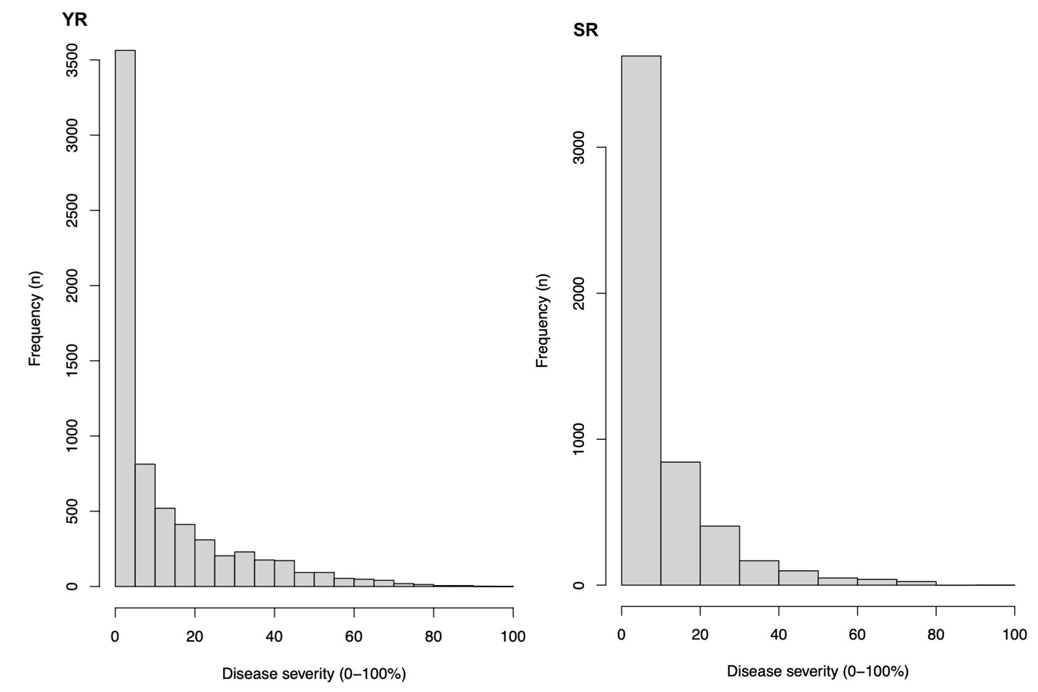
Figure S1 Frequency distributions of the 880 winter wheat genotypes for stripe rust (YR) observations and 866 genotypes for stem rust (SR) observations from selected scoring dates across environments.

