Supplementary material
Figure S.1 Net present value of net benefits (x-axis values measured in ‘000USD) without Girinka, with Girinka and under three alternative program designs
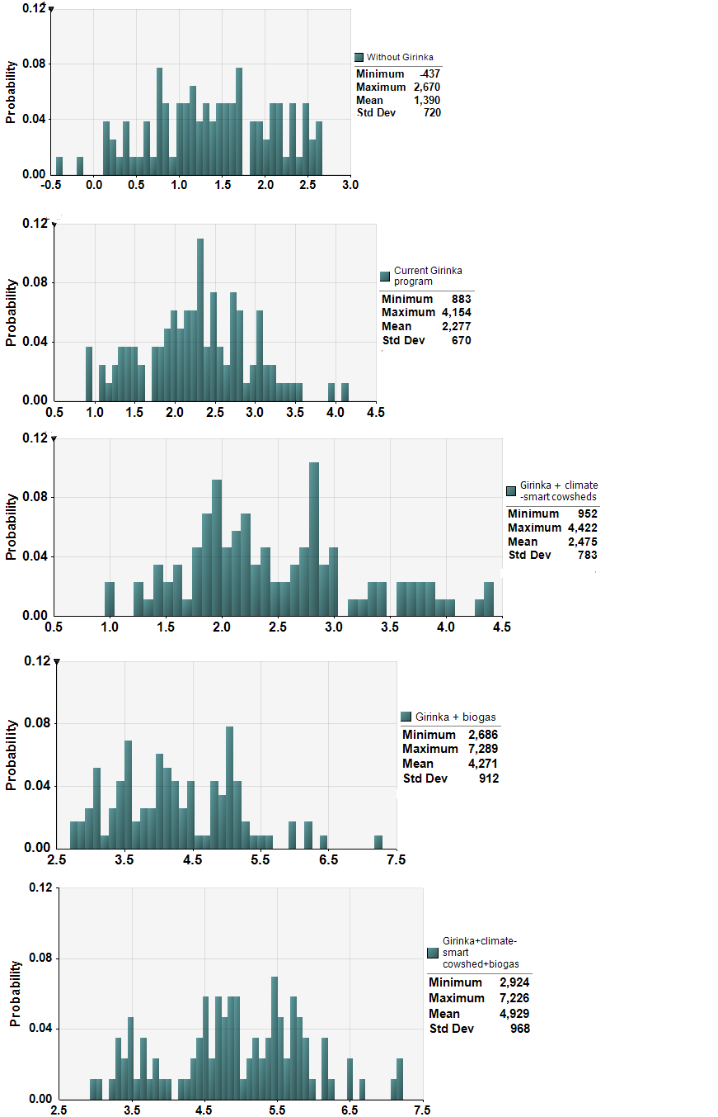

Figure S.2 Sensitivity of net benefit calculations (x-axis values measured in ‘000USD) to variability in parameter values under alternative program designs
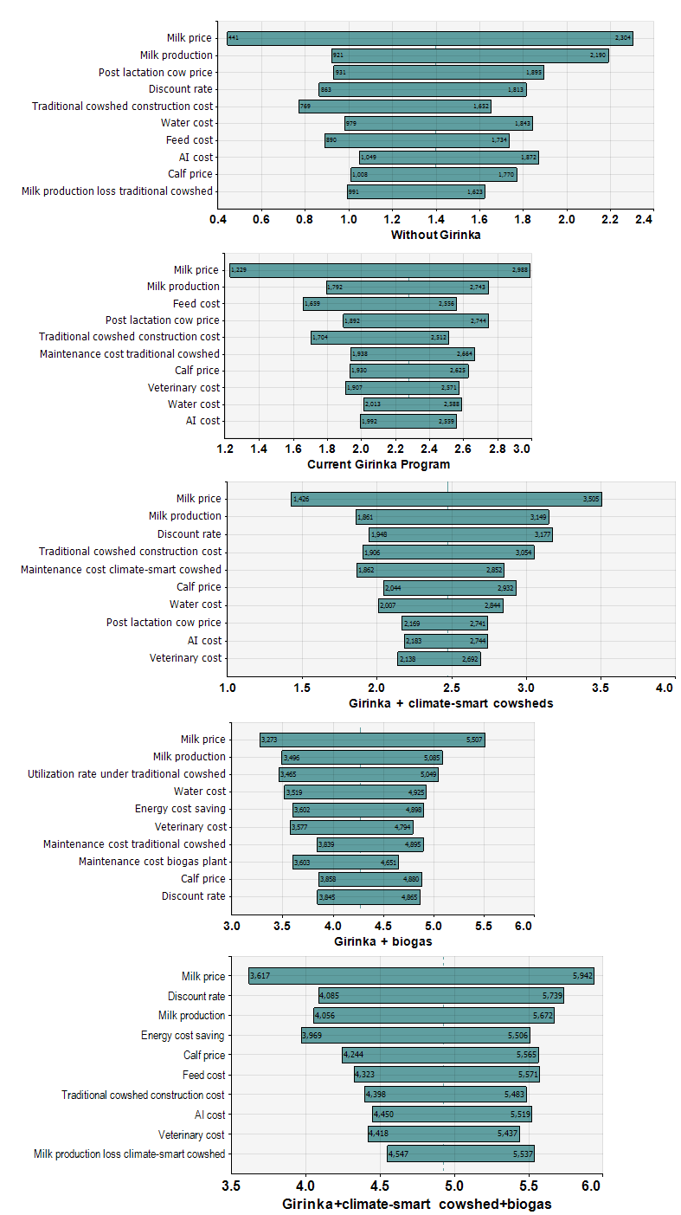
Table S.1 Description of benefits and costs considered and basic assumptions under each scenario
Scenario | Scenario description | Program costs | Household costs | Household benefits
Without project | A counterfactual scenario absent the Girinka program characterised by very few households that can afford to own a heifer with most households practicing subsistence rainfed cropping systems. Very low adoption rates for climate-smart cowsheds and biogas production plants would also be expected | No program costs incurred | Includes the cost of buying heifers, cowshed construction and maintenance, food, water artificial insemination and veterinary services and biogas plant construction and O&M costs | Revenues from milk, calves, post-lactation cow sales.
Current Girinka program | This scenario reflects the status quo where one lactating heifer is distributed to each eligible household with the minimum requirement that beneficiaries construct a traditional cowshed. Very few households with climate-smart cowsheds and biogas production plants | Includes the cost of buying and distributing heifers including transactions costs of identifying eligible beneficiary households | Construction and maintenance of a traditional low-cost cowshed, food, water and artificial insemination and veterinary services | Revenues from milk, calves, post-lactation cow sales and relatively small energy cost savings expected due to low biogas production
Girinka + climate-smart cowsheds | A counterfactual scenario that builds on the current Girinka program by providing beneficiary households with materials and labour to augment effective rainwater harvesting, flooring and waste management systems to traditional cowsheds thereby increasing manure production | Includes program costs under the current Girinka program plus additional costs of augmenting traditional cowsheds with effective rainwater harvesting, flooring and waste management systems | Construction and maintenance of a traditional cowshed, food, water and artificial insemination and veterinary services | Revenues from milk, calves, post-lactation cow sales
Girinka + biogas plants | A counterfactual scenario that builds on the current Girinka program by providing each beneficiary households with a biogas production plant in addition to lactating heifers under traditional cowshed systems | Includes program costs under the current Girinka program plus the additional costs of constructing biogas production plants for each beneficiary household | Construction and maintenance of a traditional cowshed, food, water and artificial insemination and veterinary services and biogas plant O&M costs | Revenues from milk, calves, post-lactation cow sales and energy cost savings
Girinka + climate-smart cowsheds + biogas | A counterfactual scenario that builds on the current Girinka program by providing each beneficiary households with a climate-smart cowsheds and a biogas production plant | Includes program costs under the current Girinka program plus additional climate-smart cowshed augmentation costs and construction costs for biogas production plants | Construction and maintenance of a traditional cowshed, food, water and artificial insemination and veterinary services and biogas plant O&M costs | Revenues from milk, calves, post-lactation cow sales and energy cost savings
Survey design and implementation
This study utilised primary data from a 2018 cross-sectional survey of Rwandan smallholder dairy farmers benefiting from the Girinka program. Conducted by the University of Rwanda's College of Agriculture, Animal Sciences and Veterinary Medicine, the survey aimed to understand the program's impact on household costs, income and food and nutrition security. The sample frame comprised all households that received a cow between 2014 and 2018 under the Girinka program in Rwanda's Western and Eastern Provinces. During this period, the program distributed a total of over 295,000 cows to beneficiaries in both provinces, with 297.060 recipients in the Western Province and 297,000 in the Eastern Province (RGB, 2018). A multi-stage multistage cluster sampling design was employed. All seven districts of both Eastern and Western Provinces were included in the sample. Stratified random sampling was applied at the sector level. In the Western Province, 15 of 96 sectors were randomly selected. 17 of 95 sectors were randomly selected in the Eastern Province. Within each sampled sector, further stratification and random selection were conducted. In the Western Province, 37 cells and 69 villages were chosen, while in the Eastern Province, 82 cells and 90 villages were selected.
A questionnaire was developed through a collaborative process involving University of Rwanda researchers, field experts from the Rwanda Agriculture Board, and program coordinators. The questionnaire focused on collecting the economic costs and benefits of owning a heifer, including income from milk sales, manure use, crop production, energy sources, and animal husbandry expenses. The questionnaire was pilot-tested with a small sample of the target population. Field expert consultation validated the validity of the questions. The administration involved trained enumerators conducting face-to-face interviews under the supervision of University of Rwanda experts. Tablets were used to collect data directly at respondents’ homes. This study secured ethical approval from the University of Rwanda’s Research and Postgraduate Studies Unit and the National Institute of Statistics of Rwanda. Detailed descriptive statistics for variables including household demographics, livestock holding size, and economic indicators are presented in Table S.2.
The survey achieved the intended target sample size of 2,000 respondents diverse in demographic and geographic characteristics, mitigating potential limitations arising from non-response and underrepresentation of specific groups and enhancing the generalisability of findings to the target population. For this analysis, we utilised 1,436 of the 2,000 collected responses (71.8% response rate). The remaining 564 responses were excluded for the following reasons: 1) implausible or illogical responses that raised concerns about data quality (n = 137); 2) missing observations on key variables that limited their analytical usefulness (n = 309); and 3) responses from individuals who did not meet the critical inclusion criterion of having received a cow through the Girinka program in the past four years (n = 112).
Table S.2 Descriptive summary statistics of a survey of Girinka program participants in Eastern and Western Rwandan provinces (N=1,436)
Variable name | Description | Mean | Median | SD | Min | Max
Grow crops | 1 = household grew crops, 0 = otherwise | 0.96 | 1 | 0.19 | 0 | 1
Crop area | Total crop land area operated by household (hectares/year) | 3.00 | 3.0 | 1.05 | 0 | 1
Crop sale income | 1 = household earns income from crop sales, 0 = otherwise | 0.01 | 0.00 | 0.1 | 0 | 1
Livestock sale income | 1 = household earns income from sale of livestock, 0 = otherwise | 0.00 | 0.00 | 0.04 | 0 | 1
Cultivate maize | 1 = household grows maize, 0 = otherwise | 0.70 | 1 | 0.47 | 0 | 1
Cultivate beans | 1 = household grows beans, 0 = otherwise | 0.89 | 1 | 0.31 | 0 | 1
Cultivate sweet potatoes | 1 = household grows beans, 0 = otherwise | 0.75 | 1 | 0.43 | 0 | 1
Cultivate cassava | 1 = household grows cassava, 0 = otherwise | 0.29 | 0 | 0.45 | 0 | 1
Firewood | 1 = household uses firewood as a source of energy, 0 = otherwise | 0.80 | 1 | 0.23 | 0 | 1
Charcoal | 1 = household uses charcoal as a source of energy, 0 = otherwise | 0.02 | 0 | 0.15 | 0 | 1
Solar | 1 = household uses solar as a source of energy, 0 = otherwise | 0.02 | 0 | 0.14 | 0 | 1
Electricity | 1 = household uses electricity as a source of energy, 0 = otherwise | 0.01 | 0 | 0.1 | 0 | 1
Biogas | 1 = household uses biogas as a source of energy, 0 = otherwise | 0.02 | 0 | 0.03 | 0 | 1
Pay for artificial insemination services | 1 = household pays for artificial insemination services, 0 = otherwise | 0.19 | 0 | 0.39 | 0 | 1
Cost of artificial insemination services (USD/session) | Average cost of artificial insemination services per session | 3.65 | 3.59 | 2.59 | 0.32 | 16
Cost of veterinary services (USD/visit) | Average cost of artificial insemination services per visit | 0.97 | 1 | 3.15 | 0.00 | 30
Buy feed | 1 = household pays for animal feed, 0 = otherwise | 0.12 | 0 | 0.32 | 0 | 1
Cost of feed (USD/day) | Cost of animal feed per day | 0.62 | 1 | 2.16 | 0.00 | 1.35
Cost of water (USD/day) | Cost of watering animals per day | 0.1 | 0.00 | .012 | 0.00 | 0.87
Milk production (L/day) | Average milk production per household per day | 3.32 | 3.00 | 3.47 | 0 | 26
Milk production loss rate | Average milk production loss rate per household per day | 0.15 | 0.14 | 0.07 | 0 | 0.23
Price of milk (USD/L) | Average price of milk sold by dairy households | 0.04 | 0.03 | 0.08 | 0.00 | 0.32

Table S.3 Parameter value ranges used to calculate program and household annual costs and benefits (unit costs and prices were converted to 2020 USD)
BCA Component |  | Parameter |  | Unit | Value | Source(s)
Fixed capital set-up costs
Cost of lactating heifer |  | Heifer cost |  | USD/cow | 583-1211 | (IFAD, 2016; IFC, 2007; IFRC, 2016)
Transaction costs |  | Transaction costs |  | USD/cow | 11-15 | (IFRC, 2016)
Traditional cowshed |  | Construction cost_{trad} |  | USD/  cowshed | 31-62 | (Kayigema, 2013)
 | Lifespan (traditional cowsheds) | t_{trad} | Years |  | 5 | (Kayigema, 2013)
Climate-smart cowshed |  | Construction cost_{cs} |  | USD/  cowshed | 230-282 | (IFAD, 2016)
 | Distribution cost (climate smart cowsheds) | Dist cost_{cs} | USD/  cowshed |  | 9-11 | (IFAD, 2016)
 | Lifespan (climate smart cowsheds) | t_{cs} | Years |  | 12 | (IFAD, 2016)
Construction cost biogas plant |  | Construction cost |  | USD/plant | 813-993 | (Garfi et al., 2016; Kayigema and Rugege, 2014; Mwakaje, 2008)
Distribution cost (biogas plant) |  | Dist cost_{biogas} |  | USD/plant | 33-37 | (Garfi et al., 2016)
Lifespan of biogas plant |  | t_{biogas} |  | Years | 5 | (Garfi et al., 2016)
Variable costs
Cost of feeding |  | Feed |  | USD/cow | 119-287 | Table S.2 (IFRC 2016)
Cost of water |  | Water |  | USD/cow | 11-33 | Table S.2 (Kayigema, 2013; IFAD, 2016)
Cost of artificial insemination** |  | AI |  | USD/cow | 0-16 | Table S.2 in Supplementary Material
Cost of veterinary services |  | Veterinary |  | USD/cow | 0-85 | Table S.2 (Kayigema 2013; IFAD, 2016)
Household benefits
Milk production |  | Production_{m} |  | Litres | 680-1220 | Table S.2 (Kim et al., 2011; Klapwijk et al., 2014; Paul et al., 2017))
Milk production loss (traditional cowshed) |  | Production loss_{trad} |  | % | 7-23 | Table S.2 (Juozaitienė et al., 2006)
Milk production loss (climate-smart cowshed) |  | Production loss_{cs} |  | % | 3-12 | Table S.2 (Kayigema 2013; IFAD, 2016)
Price of milk |  | Price_{m} |  | USD/Litre | 0.12-0.36 | Table S.2 (CIAT, 2016))
Price of one calf^ |  | Calf price |  | USD/calf | 112-329 | (IFC 2007; IFRC 2016)
Price of post-lactation cow |  | Cow price_{p} |  | USD/cow | 121-307 | (IFC 2007; IFRC 2016)
Lifespan of cow^^ |  | t_{p} |  | Years | 9 | (Miklyaev et al., 2017)
 | Energy cost savings | Energy cost | USD/  household |  | 177-297 | (Garfi et al., 2016; Mwakaje, 2008)
 | Utilisation (traditional) | Utilisation_{trad} | % |  | 75-85 | (IFAD, 2016)
Utilisation rate (climate-smart) |  | Utilisation_{cs} |  | % | 85-95 | (IFAD, 2016)
Notes: * Transaction costs of distribution were assumed at between 9 and 13% of cost of animal (IFRC, 2016)
** artificial insemination is not accepted and practiced by all Girinka beneficiaries with some preferring natural mating (Mwabonimana and Habimana, 2015)
^ We assumed a large range in calf price value because heifers typically cost more than bull calves
^^ Calving age estimated at 2 years, calving interval range (1.25-1.5 years) over a total of 3.3-4.5 lactation cycles (Miklyaev et al., 2017)

