SUPPORTING INFORMATION

Rainforest fragmentation decreases the robustness of plant-frugivore interaction networks

David Becker^{1,2,#}, Wande Li^{1,3}, Ashtha Gurung¹, Eduardo Rodriguez Martinez¹, Emmanuel Rojas⁴, Bernal Rodríguez-Herrera⁵, Maximilian G.R. Vollstädt ⁶, Ingo Grass^{1,2}, Thomas Hiller^{1,2}

¹Ecology of Tropical Agricultural Systems, University of Hohenheim, Garbenstrasse 13, 70599 Stuttgart, Germany
²Center for Biodiversity and Integrative Taxonomy (KomBioTa), University of Hohenheim, 70599 Stuttgart, Germany
³School of Ecological and Environmental Sciences, East China Normal University, 200241 Shanghai, China.
⁴Reserva Biológica Tirimbina, 41002 La Virgen de Sarapiquí, Heredia, Costa Rica
⁵Escuela de Biología y Centro de Investigación en Biodiversidad y Ecología Tropical (CIBET), Universidad de Costa Rica, 2060 San José, Costa Rica
⁶Instituto Mediterráneo de Estudios Avanzados (CSIC-UIB), Miquel Marqués 21, 07190 Esporles, Mallorca, Balearic Islands, Spain.

# Corresponding Author: d.becker@uni-hohenheim.de

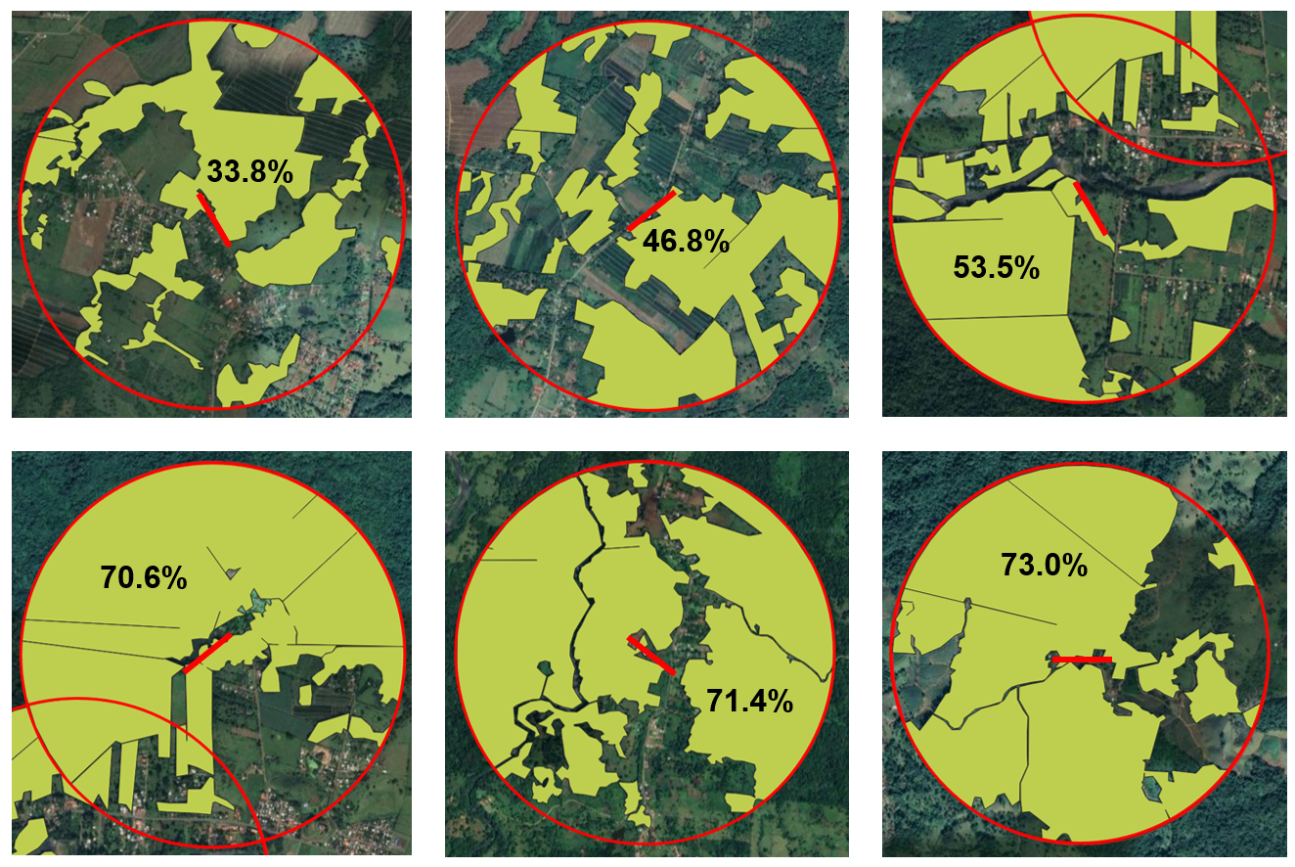
FIGURE S1: Forest cover in the surrounding landscape, depicted in bright green, within a radius of one kilometer around the center of the observation transects in each forest fragment (from top left to right in order Fragment 2, 6, 5, 3, 4, and 1). The numbers indicate the percentage of the total buffer area covered by forest, while the red bar represents the 300m observation transect.

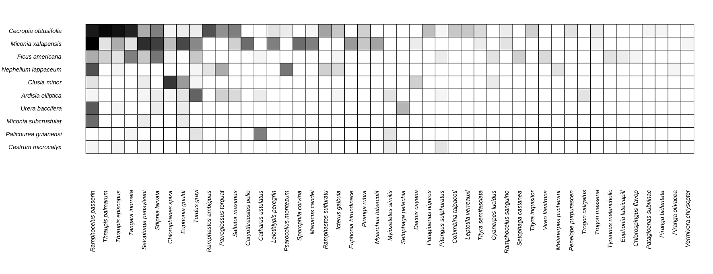

FIGURE S2: Matrix showing the interactions observed between the fruiting plant species (left) and the bird species (bottom). The darker the grey, the higher the number of interactions between the interacting partners.

TABLES
TABLE S1: Results of Wald-tests derived from generalized linear regression models, evaluating the impact of fragment size, the amount of forest in the surrounding landscape, fruit amount per tree and tree surrounding on the bird species richness, with a predetermined significance threshold of α = 0.05.
 | bird species richness
 | Est. | SE | z-value | p-value
Intercept | 0.986 | 0.177 | 5.580 | <0.001***
log10 fragment size | 0.421 | 0.158 | 2.666 | 0.008**
log10 fruit amount | 0.464 | 0.075 | 6.180 | <0.001***
tree surrounding | 0.628 | 0.139 | 4.511 | <0.001***
Conditional/Marginal R2 | 0.736/0.603
Intercept | 1.012 | 0.189 | 5.366 | <0.001***
forest cover | 0.402 | 0.172 | 2.345 | 0.019*
log10 fruit amount | 0.465 | 0.075 | 6.168 | <0.001***
tree surrounding | 0.609 | 0.140 | 4.355 | <0.001***
Conditional/Marginal R2 | 0.743/0.579

 | Forest cover |  |  |  |  | Log10 fragment size
 | Est. | SE | t-value | p-value | Adj.R2 | Est. | SE | t-value | p-value | Adj.R2
Modularity | 0.240 | 0.068 | 3.551 | 0.024* | 0.699 | 5.508 | 1.900 | 2.900 | 0.044* | 0.597
H2´ | 0.350 | 0.099 | 3.556 | 0.024* | 0.700 | 7.614 | 3.039 | 2.505 | 0.066 | 0.513
Robustness | 0.009 | 0.002 | 6.185 | 0.004* | 0.371 | 0.210 | 0.045 | 4.700 | 0.009** | 0.808
TABLE S2: Results of t-tests derived from linear regression models, evaluating the impact of fragment size and forest cover in the surrounding landscape on the network indices Modularity, H2 and Robustness, with a predetermined significance threshold of α = 0.05

TABLE S3: Species list of birds observed during this study
Group | Scientific name
Birds | Caryothraustes poliogaster Lafresnaye, 1837
Birds | Catharus minimus Ridgway, 1882
Birds | Catharus ustulatus Nuttall, 1840
Birds | Chlorophanes spiza Linnaeus, 1758
Birds | Chlorospingus flavopectus Sclater, 1857
Birds | Columbina talpacoti Temminck, 1810
Birds | Cyanerpes lucidus Gmelin, 1788
Birds | Dacnis cayana Linnaeus, 1766
Birds | Euphonia gouldi Cabanis, 1861
Birds | Euphonia hirundinacea Lesson, 1831
Birds | Euphonia luteicapilla Du Bus de Gisignies, 1847
Birds | Icterus galbula Linnaeus, 1758
Birds | Leiothlypis peregrina Wilson, 1811
Birds | Leptotila verreauxi Bonaparte, 1855
Birds | Manacus candei Lesson, 1831
Birds | Melanerpes pucherani Malherbe, 1849
Birds | Myiarchus tuberculifer d'Orbigny & Lafresnaye, 1837
Birds | Myiozetetes similis Spix, 1825
Birds | Patagioenas nigrirostris Wagler, 1831
Birds | Patagioenas subvinacea Bonaparte, 1854
Birds | Pachysylvia decurtata Cabanis, 1861
Birds | Penelope purpurascens Wagler, 1830
Birds | Piranga bidentata Swainson, 1827
Birds | Piranga olivacea Gmelin, 1789
Birds | Piranga rubra Linnaeus, 1758
Birds | Pitangus sulphuratus Linnaeus, 1766
Birds | Psarocolius montezuma Lesson, 1830
Birds | Pteroglossus torquatus Gmelin, 1788
Birds | Ramphastos ambiguus Swainson, 1822
Birds | Ramphocelus passerinii Lesson, 1831
Birds | Ramphocelus sanguinolentus Lesson, 1831
Birds | Saltator maximus Vieillot, 1819
Birds | Setophaga castanea Wilson, 1811
Birds | Setophaga pensylvanica Linnaeus, 1766
Birds | Setophaga petechia Linnaeus, 1758
Birds | Sporophila corvina Sclater & Salvin, 1869
Birds | Stilpnia larvata Vieillot, 1819
Birds | Tangara inornata Du Bus de Gisignies, 1846
Birds | Thraupis episcopus Linnaeus, 1766
Birds | Thraupis palmarum Wied-Neuwied, 1830
Birds | Tityra inquisitor Gmelin, 1788
Birds | Tityra semifasciata Sparrman, 1788
Birds | Trogon caligatus Temminck, 1822
Birds | Trogon massena Gould, 1846
Birds | Turdus grayi Cabanis, 1866
Birds | Tyrannus melancholicus Vieillot, 1808
Birds | Vermivora chrysoptera Linnaeus, 1766
Birds | Vireo flavifrons Vieillot, 1818

TABLE S4: Species list of fruit-bearing plants and the times they were observed during the study in the individual fragments.
Fragment | Tree species | Observation hours per tree species
1 | Ardisia elliptica - Thunberg, 1784 | 16
1 | Cecropia obtusifolia - Bertoloni, 1840 | 12
1 | Miconia xalapensis - (Bonpland) DC., 1817 | 8
2 | Clusia minor - Linnaeus, 1753 | 12
2 | Schlegelia parviflora - (Oerst.) Monach., 1949 | 4
2 | Pourouma cecropiifolia - Mart., 1831 | 8
2 | Urera baccifera - Gaudichaud, 1826 | 4
2 | Ficus paraensis - (Miq.) Miq., 1867 | 4
3 | Palicourea guianensis - Aublet, 1775 | 8
3 | Ficus americana - Desfontaines, 1798 | 4
3 | Cecropia obtusifolia - Bertoloni, 1840 | 12
3 | Ardisia elliptica - Thunberg, 1784 | 4
3 | Miconia xalapensis - (Bonpland) DC., 1817 | 4
4 | Palicourea guianensis - Aublet, 1775 | 4
4 | Nephelium lappaceum - Linnaeus, 1753 | 8
4 | Cecropia obtusifolia - Bertoloni, 1840 | 12
4 | Miconia xalapensis - (Bonpland) DC., 1817 | 12
5 | Cecropia obtusifolia - Bertoloni, 1840 | 16
5 | Urera baccifera - Gaudichaud, 1826 | 12
5 | Aegiphila falcata - J. Donn. Sm., 1890 | 4
6 | Cecropia obtusifolia - Bertoloni, 1840 | 20
6 | Miconia subcrustulata - Cogniaux, 1891 | 8
6 | Cestrum microcalyx - C. Presl, 1846 | 8
6 | Palicourea guianensis - Aublet, 1775 | 12

