Analysis of Protein-Network Formation of Different Vegetable Proteins during Emulsification to Produce Solid Fat Substitutes, J. Food Meas. Charact., Baune M.C., Schroeder S., Witte F., Heinz V., Bindrich U., Weiss J. and Terjung N.

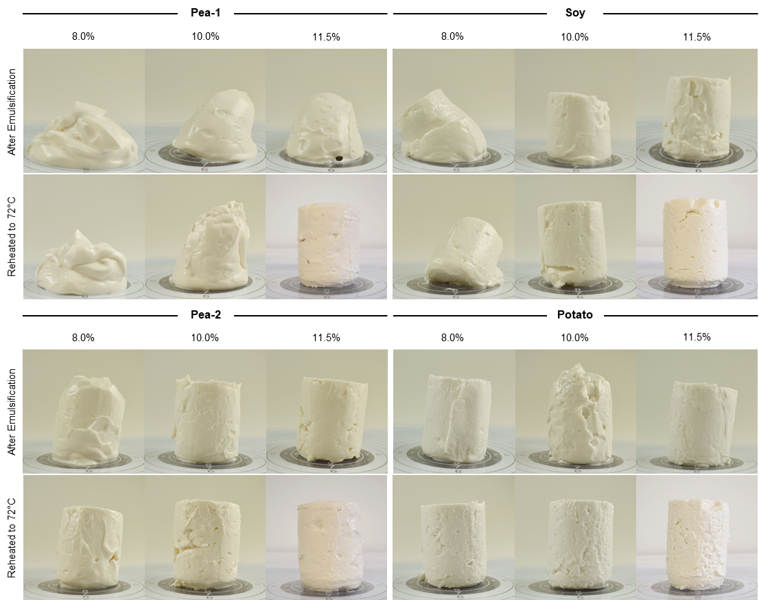
Figure S1 Appearance of the emulsion gels before and after reheating to 72°C. Shown are the emulsion gels in dependence of the protein type (Pea-1, Pea-2, Soy, Potato) and protein concentration in the continuous phase (8.0% (w/w), 10.0% (w/w),11.5% (w/w)). Emulsion gels were prepared using oil mass fraction of 70% (w/w).
Table S1 Properties of major pea, soy and potato proteins. Listed are the protein classes and their size (kDa), denaturation temperature T_{D} (°C) and pI (isoelectric point) with the references.
Protein class | Size  (kDa) | T_{D}  (°C) | pI | Reference
7S globulins (trimeric) | 150 – 190 | 60 – 70 | ~4.5 | Lam et al. [1], Barać et al. [2], Riblett et al. [3], Nishinari et al. [4]
11S globulins (hexameric) | 300 – 400 | 80 – 90 | ~4.5
2S albumins (dimeric) | 12 – 50 | >90, at neutral pH | 4.2 – 8.1 | Lam et al. [1], Djoullah et al. [5], Moreno & Clemente [6]
Patatin (glycoproteins) | 40 – 42 | ~60, at neutral pH | 4.5 – 5.2 | Alting et al. [7], Pots et al. [8]  Pouvreau et al. [9-11]
Protease inhibitors (mono-, di-, or pentameric) | 4,3 – 40 | >60 | 5.1 – >9.0 | Alting et al. [7], Pots et al. [8]  Pouvreau et al. [9-11]

Table S2 Amino acid profiles of the protein isolates in g/100 g protein. The profiles have been provided by the manufacturers.
Amino acid | Amount (g/100 g protein)
Amino acid | Pea-1 | Pea-2 | Soy | Potato
Ala | 4.4 | 4.3 | 4.1 | 2.5
Arg | 8.7 | 8.7 | 7.6 | 4.8
Asn + Asp | 11.9 | 11.5 | 11.6 | 13.0
Cys | N/D | 1.0 | 1.3 | 2.4
Gln + Glu | 17.3 | 16.8 | 19.6 | 7.8
Gly | 4.1 | 4.1 | 4.1 | 5.8
His | 2.5 | 2.5 | 2.5 | 1.8
Ile | 4.9 | 4.5 | 4.4 | 6.0
Leu | 8.5 | 8.4 | 7.8 | 9.8
Lys | 7.6 | 7.2 | 6.3 | 7.6
Met | 1.0 | 1.1 | 1.2 | 1.1
Phe | 5.7 | 5.5 | 5.6 | 7.0
Pro | 4.5 | 4.5 | 5.4 | 5.5
Ser | 5.4 | 5.3 | 5.4 | 4.8
Thr | 3.8 | 3.9 | 3.7 | 4.7
Trp | 0.8 | 1.0 | 1.3 | 1.5
Tyr | 3.8 | 3.8 | 3.8 | 5.5
Val | 5.1 | 5.0 | 4.4 | 8.6
Total | 99.9 | 99.1 | 100.0 | 100.0
thereof SAA | 1.0 | 2.1 | 2.5 | 3.5
thereof HAA | 34.8 | 34.3 | 34.1 | 41.8
SAA: sulfuric amino acids, HAA: hydrophobic amino acids
Table S3 Final protein content of the emulsions. Listed is the calculated final protein amount of the emulsions in g/100 g considering the protein concentration in the continuous phase (C_{P}C) in
g/100 g and the oil mass fraction 65 – 80 % (w/w).
C_{P}C (g/100 g) | Final Protein Content in Emulsion (g/100 g)
C_{P}C (g/100 g) | 65 % (w/w) Oil | 70 % (w/w) Oil | 75 % (w/w) Oil | 80 % (w/w) Oil
8.0 | 2.80 | 2.40 | 2.00 | 1.60
8.5 | 2.98 | 2.55 | 2.13 | 1.70
9.0 | 3.15 | 2.70 | 2.25 | 1.80
9.5 | 3.33 | 2.85 | 2.38 | 1.90
10.0 | 3.50 | 3.00 | 2.50 | 2.00
10.5 | 3.68 | 3.15 | 2.63 | 2.10
11.0 | 3.85 | 3.30 | 2.75 | 2.20
11.5 | 4.03 | 3.45 | 2.88 | 2.30

Table S4 Average particle diameter of the creamed emulsions. Listed are the volumetric mean diameters (D[4,3]) and surface mean diameters (D[3,2]) in µm of emulsion gels prepared using oil mass fraction of 70% and C_{P}C of 8.0, 10.0 or 11.5% (w/w) respectively.
C_{P}C (g/100 g) | Pea-1 |  | Pea-2 | Soy |  | Potato
C_{P}C (g/100 g) | D[4,3] (µm)
8.0 | 18.18 ± 5.27^{A,B} | 18.85 ± 5.44^{C,D} |  |  | 69.54 ± 10.23^{A,C,1} |  | 65.03 ± 29.13^{B,D}
10.0 | 19.82 ± 0.87^{A,B} | 13.23 ± 0.47^{C,D} |  |  | 91.41 ± 0.76^{A,C,E,1} |  | 46.56 ± 0.42^{B,D,E,2}
11.5 | 21.30 ± 7.27^{A,B} | 16.89 ± 1.74^{C,D} |  |  | 76.65 ± 6.44^{A,C} |  | 69.39 ± 5.63^{B,D,2}
 | D[3,2] (µm)
8.0 | 5.03 ± 0.73^{A,B} | 5.42 ± 0.62 |  |  | 9.15 ± 0.53^{A} |  | 9.26 ± 2.92^{B}
10.0 | 4.88 ± 0.21^{A} | 4.24 ± 0.37^{C} |  |  | 12.95 ± 2.13^{A,C,E} |  | 7.28 ± 0.99E
11.5 | 4.34 ± 0.56 | 4.38 ± 0.60 |  |  | 9.64 ± 3.47 |  | 8.72 ± 1.19
Means ± standard deviation were determined by triplicate analysis. Different superscripts indicate significant differences (P < 0.05): ^{A-E} between the different proteins at the same C_{P}C and ^{1,2} within the same protein at varying C_{P}C.
References
1. A.C.Y. Lam, A. Can Karaca, R.T. Tyler, M.T. Nickerson, Pea protein isolates: Structure, extraction, and functionality. Food Rev. Int. 34, 2 (2018).
2. M.B. Barać, M.B. Pešić, S.P. Stanojević, A.Z. Kostić, S.B. Čabrilo, Techno-functional properties of pea (Pisum sativum) protein isolates: A review. Acta Period. Technol. 46 (2015).
3. A.L. Riblett, T.J. Herald, K.A. Schmidt, K.A. Tilley, Characterization of β-conglycinin and glycinin soy protein fractions from four selected soybean genotypes. J. Agric. Food Chem. 49, 10 (2001).
4. K. Nishinari, Y. Fang, S. Guo, G.O. Phillips, Soy proteins: A review on composition, aggregation and emulsification. Food Hydrocoll. 39 (2014).
5. A. Djoullah, F. Husson, R. Saurel, Gelation behaviors of denaturated pea albumin and globulin fractions during transglutaminase treatment. Food Hydrocolloids 77 (2018).
6. F.J. Moreno, A. Clemente, 2S Albumin Storage Proteins: What Makes them Food Allergens? Open Biochem. J. 2 (2008).
7. A.C. Alting, L. Pouvreau, M.L.F. Giuseppin, N.H. van Nieuwenhuijzen, in Handbook of Food Proteins, ed. By Editors, (Woodhead Publishing Limited, 2011). pp. 316-334.
8. A.M. Pots, H.H.J. de Jongh, H. Gruppen, M. Hessing, A.G.J. Voragen, The pH Dependence of the Structural Stability of Patatin. J. Agric. Food Chem. 46, 7 (1998).
9. L. Pouvreau, H. Gruppen, S.R. Piersma, L.A.M. van den Broek, G.A. Van Koningsveld, A.G.J. Voragen, Relative Abundance and Inhibitory Distribution of Protease Inhibitors in Potato Juice from cv. Elkana. J. Agric. Food Chem. 49 (2001).
10. L. Pouvreau, H. Gruppen, G. van Koningsveld, L.A.M. van den Broek, A.G.J. Voragen, Conformational Stability of the Potato Serine Protease Inhibitor Group. J. Agric. Food Chem. 53, 8 (2005).
11. L. Pouvreau, T. Kroef, H. Gruppen, G. van Koningsveld, L.A.M. van den Broek, A.G.J. Voragen, Structure and Stability of the Potato Cysteine Protease Inhibitor Group (Cv. Elkana). J. Agric. Food Chem. 53, 14 (2005).

