Supplementary material
Table S1 Characterization of miscanthus and chicory
Miscanthus |  |  |  | Chicory²
 |  | %
Dry matter | 90.28 |  | ±0.07 | Dry matter | 11.77 | ±0.97
Ash¹ | 3.66 |  | ±0.16 | Ash¹ | 12.59 | ±1.33
Cellulose¹ | 49.08 |  | ±0.28 | Mono-disacharides¹ | 25.47 | ±0.11
Hemicellulose¹ | 28.02 |  | ±0.05 | Mono-disacharides¹ | 25.47 | ±0.11
Lignin¹ | 12.07 |  | ±0.47 | Fructan¹ | 4.13 | ±1.14
¹-based on dry material
²-adapted from (Stökle and Kruse, 2019)

 | Temperature (°C) | Time (min) | pH | Sugar conversion  (%) |  |  | HMF selectivity (%) |  |  | HMF yield (%)
Fru1 | 180 | 14 | 2 | 43.0 | ± | 1.3 | 72.7 | ± | 2.2 | 31.2 | ± | 0.0
Fru2 | 200 | 14 | 2 | 68.9 | ± | 1.5 | 57.7 | ± | 0.7 | 39.7 | ± | 0.4
Fru3 | 180 | 18 | 2 | 47.2 | ± | 2.8 | 71.5 | ± | 4.3 | 33.6 | ± | 0.0
Fru4 | 200 | 18 | 2 | 89.8 | ± | 1.6 | 62.9 | ± | 0.6 | 56.5 | ± | 0.5
Fru5* | 180 | 24 | 2 | 73.3 | ± | 2.5 | 67.3 | ± | 2.7 | 49.3 | ± | 0.3
Fru6* | 200 | 24 | 2 | 87.6 | ± | - | 48.7 | ± | - | 42.6 | ± | -
Fru7 | 180 | 14 | 3 | 15.1 | ± | 0.3 | 61.6 | ± | 1.7 | 9.3 | ± | 0.4
Fru8 | 200 | 14 | 3 | 40.6 | ± | 5.3 | 60.0 | ± | 2.9 | 24.5 | ± | 4.1
Fru9 | 180 | 18 | 3 | 24.5 | ± | 1.2 | 61.1 | ± | 5.4 | 15.0 | ± | 2.1
Fru10* | 200 | 18 | 3 | 71.7 | ± | 0.4 | 58.8 | ± | 2.5 | 42.2 | ± | 2.0
Fru11 | 180 | 24 | 3 | 37.7 | ± | 0.1 | 60.1 | ± | 1.7 | 22.6 | ± | 0.7
Fru12* | 200 | 24 | 3 | 84.4 | ± | 0.6 | 58.2 | ± | 0.4 | 49.1 | ± | 0.7
Glu1 | 200 | 14.4 | 2 | 17.7 | ± | 0.1 | 38.8 | ± | 1.2 | 6.8 | ± | 0.2
Glu2 | 210 | 14.4 | 2 | 31.1 | ± | 1.4 | 39.1 | ± | 3.6 | 12.1 | ± | 0.6
Glu3 | 200 | 18 | 2 | 21.4 | ± | 1.7 | 41.1 | ± | 4.7 | 8.7 | ± | 0.3
Glu4 | 210 | 18 | 2 | 43.1 | ± | 0.7 | 31.1 | ± | 0.4 | 13.4 | ± | 0.4
Glu5* | 200 | 24 | 2 | 37.5 | ± | 0.5 | 37.8 | ± | 0.9 | 14.2 | ± | 0.1
Glu6* | 210 | 24 | 2 | 48.2 | ± | 1.2 | 33.7 | ± | 3.7 | 16.2 | ± | 1.4
Glu7 | 200 | 14.4 | 3 | 19.6 | ± | 2.0 | 37.7 | ± | 4.0 | 7.3 | ± | 0.0
Glu8 | 210 | 14.4 | 3 | 36.5 | ± | 2.4 | 47.8 | ± | 3.5 | 17.4 | ± | 0.1
Glu9 | 200 | 18 | 3 | 28.6 | ± | 1.5 | 45.6 | ± | 1.5 | 13.0 | ± | 0.2
Glu10 | 210 | 18 | 3 | 36.3 | ± | 1.4 | 49.9 | ± | 2.8 | 18.1 | ± | 0.3
Glu11 | 200 | 24 | 3 | 31.8 | ± | 1.2 | 45.6 | ± | 2.7 | 14.4 | ± | 0.3
Glu12 | 210 | 24 | 3 | 44.4 | ± | 3.5 | 40.5 | ± | 3.3 | 17.9 | ± | 0.0
Table S2 Obtained molar sugar conversion, HMF selectivity, and HMF yield for each trial
*High formation of solid particles were observed
All data are presented as mean ± standard deviation (n = 3).
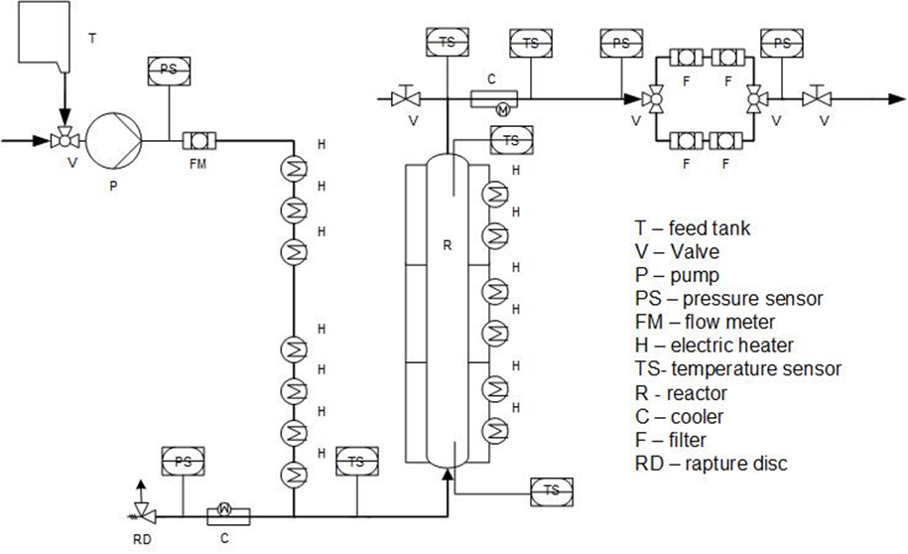
Figure S 1 Process flow diagram of HMF synthesis unit

