Additional file 1

Recombinant production of acidophilic L-arabinose isomerase from Lentilactobacillus parakefiri in Bacillus subtilis

Nathanael Weber¹, Sebastian Götz^{1,2}, Jana Senger¹, Sabine Lutz-Wahl¹ and Lutz Fischer¹*

¹University of Hohenheim, Institute of Food Science and Biotechnology, Department of Biotechnology and Enzyme Science, Garbenstr. 25, 70599 Stuttgart, Germany

²Present address: Biberach University of Applied Sciences, Institute for Applied Biotechnology, Karlstr. 11, 88400 Biberach, Germany

*Corresponding author:

Table S1. Primer sequences used in this study.
Primer | Sequence (5' -> 3')
P1 | cgactagtatgttacaagtacctgattatg
P2 | gctcgagttattacttgatgtcgttaaatg
P3 | cggaattcccatcacatatacctg
P4 | ggactagtcatgtctccttttttatg
P5 | ctcaggaattcttctgtacaccaatgtcatg
P6 | gtactagtttttgcctcctaacttaagaataag
P7 | ctgaattccgtaaattccgtgagcagg
P8 | cgcgcgccgtctctctagtttataacgctcctctatcatcacac
P9 | gacatttaacgacatcaagtaataaacataaaaaaccggcc
P10 | cataatcaggtacttgtaacatttataacgctcctctatcatc
P11 | gatgatagaggagcgttataaatgttacaagtacctgattatg
P12 | ccaaggccggttttttatgtttattacttgatgtcgttaaatgtc
P13 | aaggccaacgaggccgcatgagccttggaattgac
P14 | aaggccttcagggcctctccttaattacaaagcgc
P15 | aaggccctgaaggccctagtctgcagtgcaggctag
P16 | aaggccttattggcccaccgttatgcctccgccg
P17 | aaggccaacgaggccctgtcagatgtgctacaatgac
P18 | aaggccttcagggcccattctagatcctccgtctgc
P19 | aaggccctgaaggccgctcatcaacagcttgacac
P20 | aaggccttattggccgaagatcgccattgaacagc

Table S2. Plasmids used in this study.
Plasmid | Description | Reference
pLF_P_{AprE}_AprE | Negative control | [1]
pLF_P_{AprE}_L-AI-Lp | Expression of L-AI-Lp | This work
pLF_P_{SecA}_L-AI-Lp | Expression of L-AI-Lp | This work
pLF_P_{SacB}_L-AI-Lp | Expression of L-AI-Lp | This work
pLF_P_{ManP}_L-AI-Lp | Expression of L-AI-Lp | This work
pJOE8999 | CRISPR/Cas9 plasmid for B. subtilis | [2]
pJOE8999_sgSigF | CRISPR/Cas9 plasmid with integrated sgRNA for sigF | [3]
pJOE8999_sgSfp | CRISPR/Cas9 plasmid with integrated sgRNA for sfp | [3]
pJOE8999_DsigF | CRISPR/Cas9 plasmid for deletion of sigF | This work
pJOE8999_Dsfp | CRISPR/Cas9 plasmid for deletion of sfp | This work

Table S3. Recombinant B. subtilis strains used in this study.
Designation | Strain | Plasmid | Promoter
Bs007-Ap | B. subtilis 007 | pLF_P_{AprE}_L-AI-Lp | P_{AprE}
Bs007-Se | B. subtilis 007 | pLF_P_{SecA}_L-AI-Lp | P_{SecA}
Bs007-Sa | B. subtilis 007 | pLF_P_{SacB}_L-AI-Lp | P_{SacB}
Bs007-Ma | B. subtilis 007 | pLF_P_{ManP}_L-AI-Lp | P_{ManP}
Bs007∆ss-Ap | B. subtilis 007 ∆sfp ∆sigF | pLF_P_{AprE}_L-AI-Lp | P_{AprE}
Bs007∆ss-nc | B. subtilis 007 ∆sfp ∆sigF | pLF_P_{AprE}_AprE | P_{AprE}
Bs168-Ap | B. subtilis 168 | pLF_P_{AprE}_L-AI-Lp | P_{AprE}
Bs168-nc | B. subtilis 168 | pLF_P_{AprE}_AprE | P_{AprE}

Figure S1. Schematic overview of the constructed expression plasmids. The plasmids were constructed based on a modular expression cassette previously integrated into the pLF shuttle vector [1]. Amp^{R}: ampicillin resistance. ori pBR322: origin of replication derived from pBR322. Neo^{R}: neomycin resistance. rep: replication initiation gene from pUB110. ori pUB110: origin of replication derived from pUB110. The figure is based on Senger et al. with modifications [1].

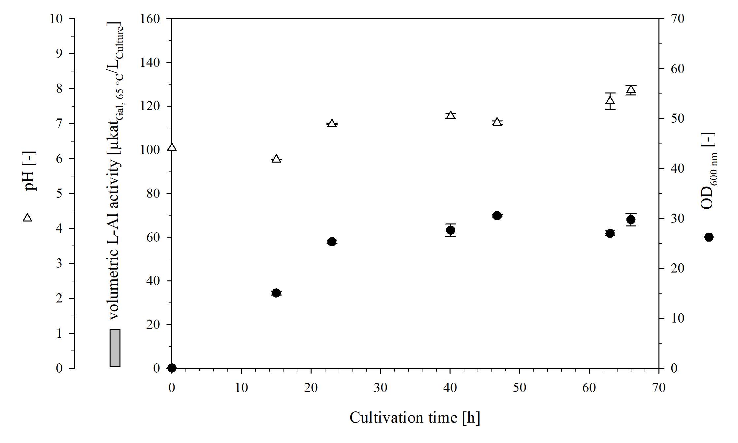
Figure S2. Shake flask cultivation of Bs007∆ss-nc. The batch cultivation was done with a working volume of 150 mL at 30 °C.

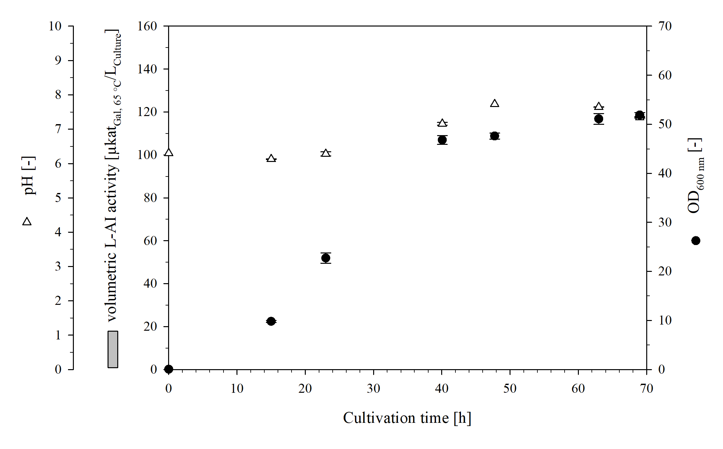
Figure S3. Shake flask cultivation of Bs168-nc. The batch cultivation was done with a working volume of 150 mL at 30 °C.
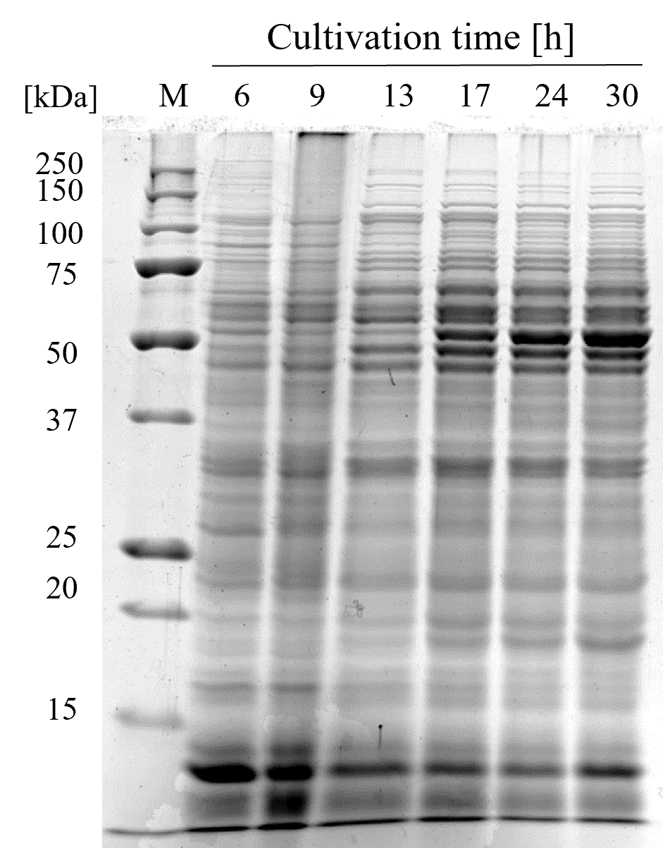
Figure S4. SDS-PAGE analysis of the cell-free extracts from bioreactor cultivation of Bs007∆ss-Ap with pH 7 and DO > 30%. M: precision Plus Protein™ unstained protein standard.

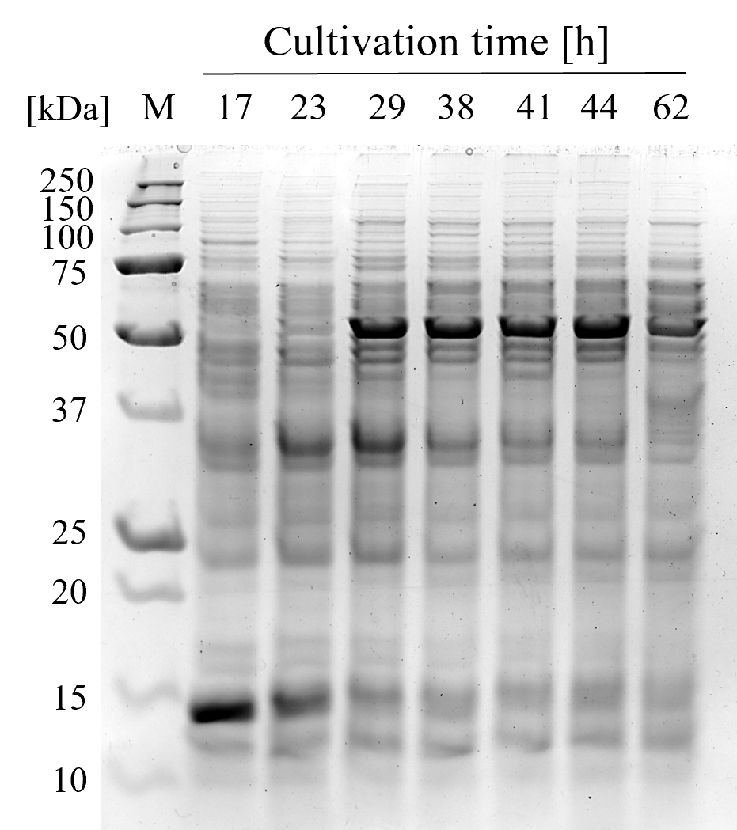
Figure S5. SDS-PAGE analysis of the cell-free extracts from bioreactor cultivation of Bs007∆ss-Ap with unregulated pH and DO ≤ 5%. M: precision Plus Protein™ unstained protein standard.

Reference
1. Senger J, Seitl I, Pross E, Fischer L. Secretion of the cytoplasmic and high molecular weight β-galactosidase of Paenibacillus wynnii with Bacillus subtilis. Microb Cell Fact. 2024;23:170.
2. Altenbuchner J. Editing of the Bacillus subtilis genome by the CRISPR-Cas9 system. Appl Environ Microbiol. 2016;82(17):5421–7.
3. Senger J, Keutgen M, Roth N, Seitl I, Fischer L. Toward food-grade production of the Bacteroides helcogenes protein-glutamine glutaminase with an optimized Bacillus subtilis strain. Research Square 2025; Preprint (Version 1).

