Supplementary material to the publication
Impact of Plastic Rain Shields and Exclusion Netting on Pest Dynamics and Implications for Pesticide Use in Apples
by
Robert Bischoff, Hans-Peter Piepho, Christian Scheer, and Georg Petschenka
Table of contents

I.Supplementary figures 3
Fig. S1. Layout of the experimental orchard 3
Fig. S2. Temperature and relative humidity of the experimental orchard in 20220 and 2023 4
Fig. S3. Mean fruit yields of all cultivars (2021 to 2023) in kg ha⁻¹ separated by cover systems 5
Fig. S4 Pyhtoseidae sampling (2018-2020) 5
II. Supplementary Tables 6
Table S1 Exact dates of beating tray samples 6
Table S2 Fresh weights of arthropods in mg 7
III. Statistical Code 8
III.a Analysis of pathogen and pest incidence 8
III.b Analysis of yields 8
III.c Analysis of insect counts (exemplary for Anthocoridae) 8
III.d Analysis of metabolic rates, including delta method 9
IV. Application of the delta method 13
References 15

I.Supplementary figures

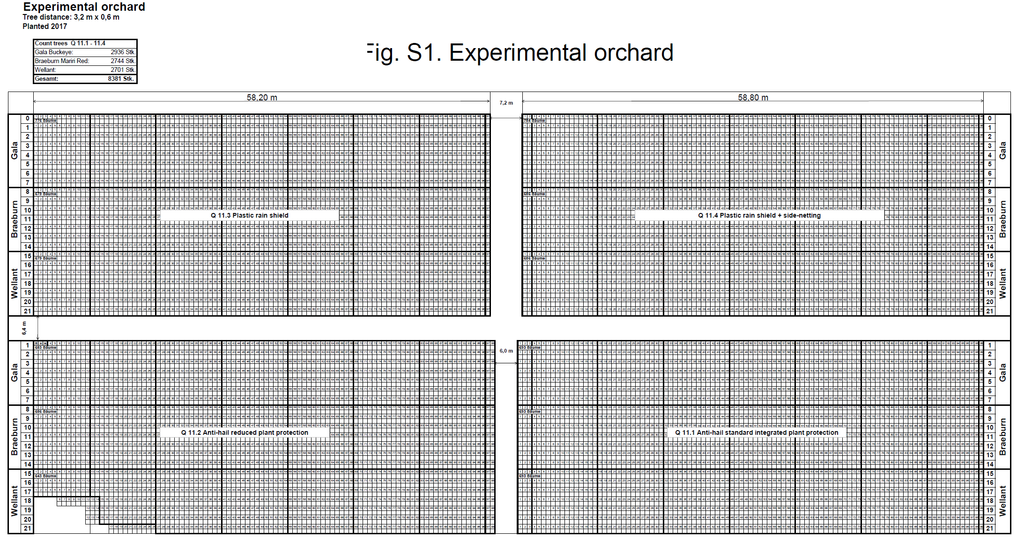
Fig. S1. Layout of the experimental orchard

Block 3
Block 4
Block 2
Block 1

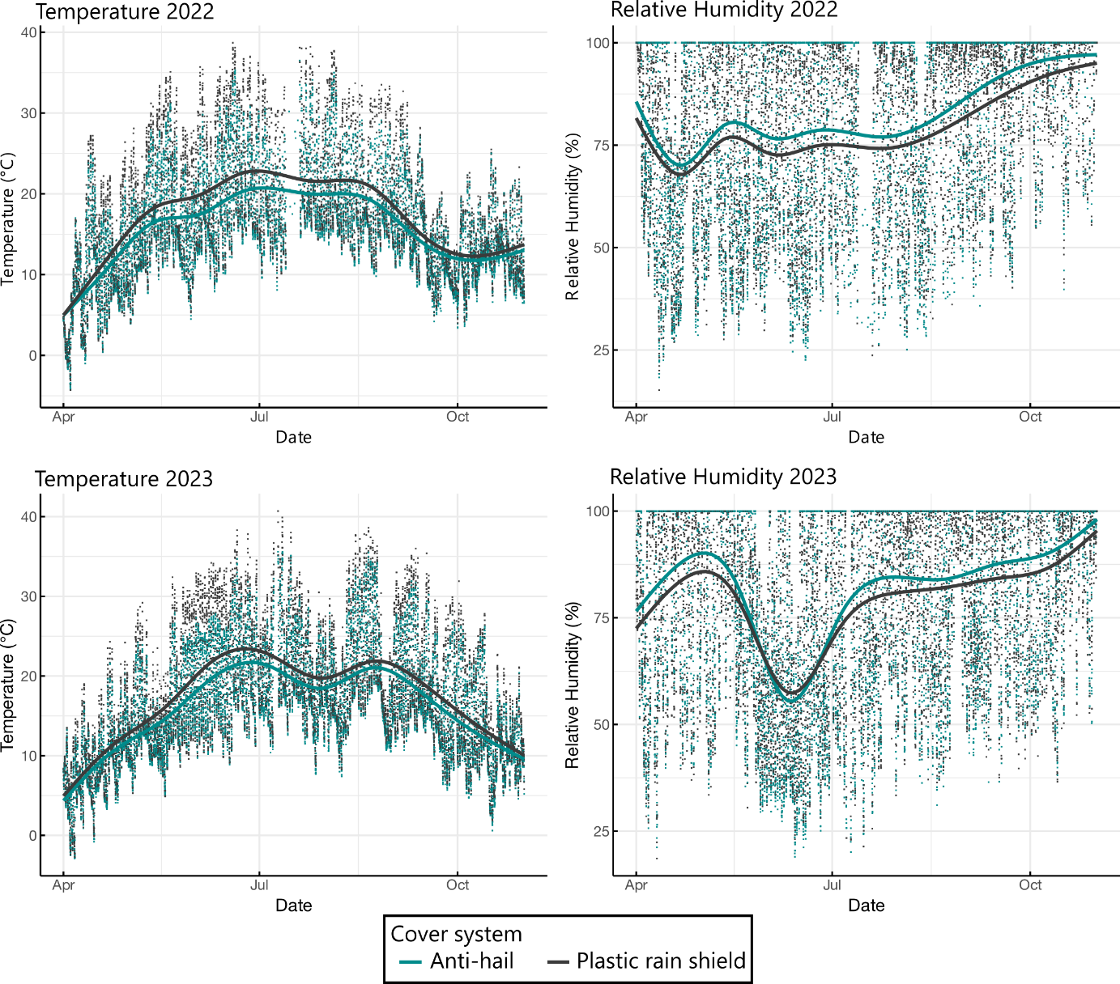

Fig. S2. Temperature and relative humidity of the experimental orchard in 20220 and 2023

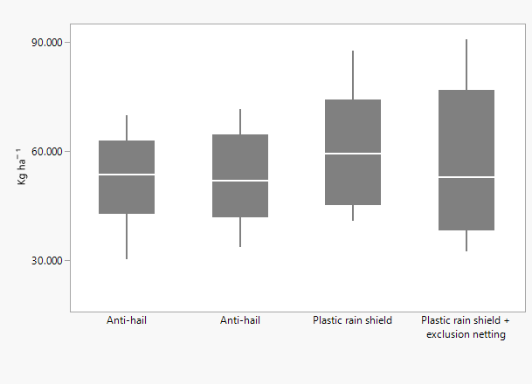

Fig. S3. Mean fruit yields of all cultivars (2021 to 2023) in kg ha⁻¹ separated by cover systems
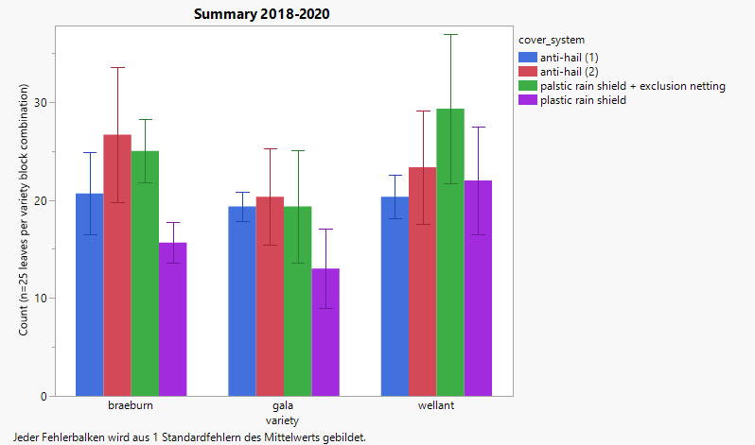

Fig. S4 Pyhtoseidae sampling (2018-2020)

II. Supplementary Tables

Table S1 Exact dates of beating tray samples
 | DE | Sampling
2022 | 02.-03.05. | 1
 | 06.06-10.06. | 2
 | 10.08. | 3
 | 19.-21.09 | 4
2023 | 3.-5.05. | 1
 | 06.06. | 2
 | 10.08. | 3
 | 10.10.* | 4
* Braeburn could not be sampled, as it was not harvested yet

Table S2 Fresh weights of arthropods in mg
Taxon | Class | Male | Female | Average | Reference
Araneae | Predator |  |  | 10 | (Meissle & Romeis 2009)
Opiliones | Predator |  |  | 0.020402 | (Ehnes et al. 2011)
Aphididae | Herbivore |  |  | 1.488 | (Brown & Llewellyn 1985) |  |  | Aptera on deciduous trees average value, throughout season
E. lanigerum | Herbivore |  |  |  |  |  |  | Aphididae weight imputed
Psyllidae | Herbivore |  |  |  |  |  |  | Aphididae weight imputed
Auchenorrhyncha | Herbivore |  |  |  |  |  |  | Aphididae weight imputed
Anthocoridae | Predator | 0.48 | 0.41 | 0.445 | (Bonte & Clercq 2011) |  |  | Based on Orius laevigatus fed on E. kuehniella eggs
S. pusillus | Predator | 0.147 | 0.18 | 0.1635 | (Ebrahimifar et al. 2020) |  |  | S. gilvifrons on artificial diet “3”
F. auricularia | Predator | 49.9 | 46.7 | 48.3 | (Le Navenant et al. 2021)
Tetranychus urticae | Herbivore |  |  | 0.0245 | (Mitchell 1973)
P. ulmi | Herbivore |  |  |  |  |  |  | T. urticae weight imputed
B. rubrioculusb | Herbivore |  |  |  |  |  |  | T. urticae weight imputed
A. baccarum | Predator |  |  | 0.021 | (Ehnes et al. 2011) |  |  | Phytoseiulus persimilis weight imputed

III. Statistical Code

III.a Analysis of pathogen and pest incidence
Nectria canker
proc glimmix data=nectria plots=studentpanel maxopt=100;
class date quarter variety organ;
model infected/tree_sampled=quarter|variety|organ@1 /dist=binomial solution;
lsmeans quarter /lines ilink adjust=tukey;;
run;

Codling moth
proc glimmix data=cydia plots=studentpanel maxopt=100;
ods output lsmeans=lsmeans;
class date quarter variety type;
model damaged/sampled=quarter /dist=binomial solution;
random int / sub=date;
lsmeans quarter /lines ilink adjust=tukey;
run;

III.b Analysis of yields
proc glimmix data=yields plots=studentpanel;
class quarter variety year;
model yield = quarter variety year quarter*year;
lsmeans quarter /pdiff lines adjust=tukey;
run;

III.c Analysis of insect counts (exemplary for Anthocoridae)

proc glimmix data=kob plots=studentpanel maxopt=100 lognote method=laplace;
ods output lsmeans=lsmeans covparms=var;
where taxon="anthocoridae";
class quarter variety taxon row date variety year date_full;
model count = quarter variety date_full /s dist=negbin link=log solution ;
random int /sub=date_full*quarter*variety;
lsmeans quarter/lines ilink adjust=tukey;
lsmeans variety/lines ilink adjust=tukey;
run;

/*Correcting means by random effect*/

data F;
set var;
if CovParm="Intercept";
factor=exp(estimate/2);
proc print;
var factor;
run;

data ant;
if _N_=1 then set F;
set lsmeans;
taxon="anthocoridae";
mu_adjusted=factor*mu;
StdErrAdjMu=factor*StdErrMu;
proc print;
run;

III.d Analysis of metabolic rates, including delta method
/*Calculating mean counts*/

proc glimmix data=m1 plots=pearsonpanel maxopt=50 method=laplace;
ods output lsmeans=lsmeans covparms=cp;
class quarter date_y taxon class variety ;
model count=quarter|taxon date_y/link=log dist=negbin htype=1;
random int /sub=date_y*quarter*variety;
parms (.1)(.1);
lsmeans taxon*quarter/ilink cov;
run;

data F;
set cp;
if CovParm="Intercept";
factor=exp(estimate/2);
proc print;
var factor;
run;
data mus;
if _N_=1 then set F;
set lsmeans;
mu_adjusted=factor*mu;
StdErrAdjMu=factor*StdErrMu;
proc print;
run;

proc sort data=m1 out=energy(keep= quarter taxon energy_use class) nodupkey;
by quarter taxon;
run;

data mus2;
merge mus energy;
by quarter taxon;
run;

/*Delta Method*/

data var_eta;
set lsmeans;
keep cov1-cov36;
run;

data mu;
set mus2;
keep mu;
run;

proc iml;
use var_eta;
read all var _num_ into var_eta;
close var_eta;
use mu;
read all var _num_ into mu;
close mu;
n=nrow(mu);
D=j(n,n,0);
do i=1 to n;
D[i,i]=mu[i];
end;
var_mu=D*var_eta*D;
create var_mu from var_mu;
append from var_mu;
close var_mu;
print mu var_eta var_mu;
run;
quit;

data var_mu;
set var_mu;
parm=1;
row=_N_;
run;

proc sort data=energy;
by quarter taxon ;
run;

proc means data=energy noprint;
var energy_use;
by quarter taxon;
output out=et2 mean=eu;
run;

proc print data=et2;
run;

proc glimmix data=mus2;
class quarter taxon;
model mu=quarter*taxon/noint solution;
random quarter*taxon/ subject=int ldata=var_mu type=LIN(1) residual;
parms (1)/hold=1;
/* to obtain means multiply with F = 1.0470902913 */
estimate 'mean quarter=1' quarter*taxon 0.00427 0.00011 0.01066 0.04735 0.01066 0.00012 0.14958 0.01066 0.00041 0.00012 0.01066 0.002
0 0 0 0 0 0 0 0 0 0 0 0
0 0 0 0 0 0 0 0 0 0 0 0/divisor=0.9550274778 df=1e5;
estimate 'mean quarter=2' quarter*taxon 0 0 0 0 0 0 0 0 0 0 0 0
0.00427 0.00011 0.01066 0.04735 0.01066 0.00012 0.14958 0.01066 0.00041 0.00012 0.01066 0.002
0 0 0 0 0 0 0 0 0 0 0 0/divisor=0.9550274778 df=1e5;
estimate 'mean quarter=3' quarter*taxon 0 0 0 0 0 0 0 0 0 0 0 0
0 0 0 0 0 0 0 0 0 0 0 0
0.00505 0.00012 0.01262 0.05676 0.01262 0.00014 0.17696 0.01262 0.00049 0.00014 0.01262 0.00236
/df=1e5 divisor=0.9550274778;

estimate 'mean quarter=1 minus mean quarter=2'
quarter*taxon 0.00427 0.00011 0.01066 0.04735 0.01066 0.00012 0.14958 0.01066 0.00041 0.00012 0.01066 0.002
-0.00427 -0.00011 -0.01066 -0.04735 -0.01066 -0.00012 -0.14958 -0.01066 -0.00041 -0.00012 -0.01066 -0.002
0 0 0 0 0 0 0 0 0 0 0 0/df=1e5;
estimate 'mean quarter=1 minus mean quarter=3'
quarter*taxon 0.00427 0.00011 0.01066 0.04735 0.01066 0.00012 0.14958 0.01066 0.00041 0.00012 0.01066 0.002
0 0 0 0 0 0 0 0 0 0 0 0
-0.00505 -0.00012 -0.01262 -0.05676 -0.01262 -0.00014 -0.17696 -0.01262 -0.00049 -0.00014 -0.01262 -0.00236/ df=1e5;
estimate 'mean quarter=2 minus mean quarter=3'
quarter*taxon 0 0 0 0 0 0 0 0 0 0 0 0
0.00427 0.00011 0.01066 0.04735 0.01066 0.00012 0.14958 0.01066 0.00041 0.00012 0.01066 0.002
-0.00505 -0.00012 -0.01262 -0.05676 -0.01262 -0.00014 -0.17696 -0.01262 -0.00049 -0.00014 -0.01262 -0.00236/df=1e5;

estimate 'mean herbivores' quarter*taxon 0 0 0.01066 0 0.01066 0.00012 0 0.01066 0 0.00012 0.01066 0
0 0 0.01066 0 0.01066 0.00012 0 0.01066 0 0.00012 0.01066 0
0 0 0.01262 0 0.01262 0.00014 0 0.01262 0 0.00014 0.01262 0
/divisor=0.9550274778 df=1e5;

estimate 'mean predators' quarter*taxon 0.00427 0.00011 0 0.04735 0 0 0.14958 0 0.00041 0 0 0.002
0.00427 0.00011 0 0.04735 0 0 0.14958 0 0.00041 0 0 0.002
0.00505 0.00012 0 0.05676 0 0 0.17696 0 0.00049 0 0 0.00236/divisor=0.9550274778 df=1e5;

estimate 'predators vs herbivores'
quarter*taxon 0.00427 0.00011 -0.01066 0.04735 -0.01066 -0.00012 0.14958 -0.01066 0.00041 -0.00012 -0.01066 0.002
0.00427 0.00011 -0.01066 0.04735 -0.01066 -0.00012 0.14958 -0.01066 0.00041 -0.00012 -0.01066 0.002
0.00505 0.00012 -0.01262 0.05676 -0.01262 -0.00014 0.17696 -0.01262 0.00049 -0.00014 -0.01262 0.00236
/df=1e5;

estimate 'herbivores: antihail1 vs antihail2'
quarter*taxon 0 0 0.01066 0 0.01066 0.00012 0 0.01066 0 0.00012 0.01066 0
0 0 -0.01066 0 -0.01066 -0.00012 0 -0.01066 0 -0.00012 -0.01066 0
0 0 0 0 0 0 0 0 0 0 0 0 /df=1e5;

estimate 'herbivores: antihail1 vs plastic-sheet'
quarter*taxon 0 0 0.01066 0 0.01066 0.00012 0 0.01066 0 0.00012 0.01066 0
0 0 0 0 0 0 0 0 0 0 0 0
0 0 -0.01262 0 -0.01262 -0.00014 0 -0.01262 0 -0.00014 -0.01262 0 /df=1e5;

estimate 'herbivores: antihail2 vs plastic-sheet'
quarter*taxon 0 0 0 0 0 0 0 0 0 0 0 0
0 0 0.01066 0 0.01066 0.00012 0 0.01066 0 0.00012 0.01066 0
0 0 -0.01262 0 -0.01262 -0.00014 0 -0.01262 0 -0.00014 -0.01262 0 /df=1e5;

estimate 'predators: antihail1 vs antihail2' quarter*taxon
0.00427 0.00011 0 0.04735 0 0 0.14958 0 0.00041 0 0 0.002
-0.00427 -0.00011 0 -0.04735 0 0 -0.14958 0 -0.00041 0 0 -0.002
0 0 0 0 0 0 0 0 0 0 0 0 /df=1e5;
estimate 'predators: antihail1 vs plastic-sheet' quarter*taxon
0.00427 0.00011 0 0.04735 0 0 0.14958 0 0.00041 0 0 0.002
0 0 0 0 0 0 0 0 0 0 0 0
-0.00505 -0.00012 0 -0.05676 0 0 -0.17696 0 -0.00049 0 0 -0.00236/df=1e5;
estimate 'predators: antihail2 vs plastic-sheet' quarter*taxon
0 0 0 0 0 0 0 0 0 0 0 0
0.00427 0.00011 0 0.04735 0 0 0.14958 0 0.00041 0 0 0.002
-0.00505 -0.00012 0 -0.05676 0 0 -0.17696 0 -0.00049 0 0 -0.00236/df=1e5;

run;

IV. Application of the delta method
Let the vector of means on the log-link scale for block-taxon combinations be given by $η$ with elements $η_{ij}$ for the i-th block and j-th taxon. Assume that the vector is first ordered by blocks and then by taxa within blocks. Then the means on the original scales are defined by $μ_{ij}=\exp\left(η_{ij}\right)$. Note that in case the linear predictor $η_{ij}$ comprises random effects, these predicted means would need to be multiplied by a factor $F=\exp\left(v/2\right)$, where v is the sum of the variance components, thus accounting for the log-normality of the back-transformed linear predictor. As regards statistical inference for pairwise comparisons among means, however, this factor can be ignored as it is the same for all means and hence has no effect on the p-values. The fitted GLMM provides the estimate of $η$, denoted as $\hat{η}$, along with its asymptotic variance-covariance matrix, denoted here as $\operatorname{var}\left(\hat{η}\right)$. Then by the delta method, the asymptotic variance-covariance matrix of the estimated means ${\hat{μ}}_{ij}=\exp\left({\hat{η}}_{ij}\right)$ is (Agresti 2002, p. 581)
$\operatorname{var}\left(\hat{μ}\right)≈C=D_{μ}\operatorname{var}\left(\hat{η}\right)D_{μ}$ (A1)
with $D_{μ}=diag\left(\frac{∂μ_{ij}}{∂η_{ij}}=μ_{ij}\right)$. Next, our means across taxa for the i-th block can be written as the linear combination
$μ_{i}=m_{1}μ_{i1}+m_{2}μ_{i2}+...+m_{12}μ_{i12}$, (A2)
where m_{j} is the metabolic rate of the j-th taxon. This can be written in matrix form as
$μ_{i}=λ_{i}^{T}μ$, (A3)
where $λ_{i}$ is a vector with elements $m_{1}$ to $m_{14}$ for the 12 taxa at the i-th block and zeros in all positions for the other blocks. The asymptotic variance of the estimate of $μ_{i}$ is
$\operatorname{var}\left({\hat{μ}}_{i}\right)≈λ_{i}^{T}Cλ_{i}$. (A4)
Likewise, the pairwise comparison of two blocks i and h can be written
$μ_{i}-μ_{h}=λ_{ih}^{T}μ$ (A5)
where is a vector with elements to for the 12 taxa at the i-th block, and with elements $-m_{1}$ to $-m_{12}$ for the 12 taxa at the i-th block, and zeros in all positions for the other blocks. The asymptotic variance of the estimate of $μ_{i}-μ_{h}$ is
$\operatorname{var}\left({\hat{μ}}_{i}-{\hat{μ}}_{h}\right)≈λ_{ih}^{T}Cλ_{ih}$. (A6)

References
Agresti, A., 2002. Categorical Data Analysis (Second edition). Wiley series in probability and statistics. John Wiley & Sons. https://doi.org/10.1002/0471249688
Bonte, M., Clercq, P. de, 2011. Influence of predator density, diet and living substrate on developmental fitness of Orius laevigatus. J. Appl. Entomol. 135, 343–350. https://doi.org/10.1111/j.1439-0418.2010.01554.x
Brown, V.K., Llewellyn, M., 1985. Variation in Aphid Weight and Reproductive Potential in Relation to Plant Growth Form. J. Anim. Ecol. 54, 651. https://doi.org/10.2307/4505
Ebrahimifar, J., Shishehbor, P., Rasekh, A., Hemmati, S.A., Riddick, E.W., 2020. Effects of Three Artificial Diets on Life History Parameters of the Ladybird Beetle Stethorus gilvifrons, a Predator of Tetranychid Mites. Insects. 11. https://doi.org/10.3390/insects11090579
Ehnes, R.B., Rall, B.C., Brose, U., 2011. Phylogenetic grouping, curvature and metabolic scaling in terrestrial invertebrates. Ecol. Lett. 14, 993–1000. https://doi.org/10.1111/j.1461-0248.2011.01660.x
Le Navenant, A., Brouchoud, C., Capowiez, Y., Rault, M., Suchail, S., 2021. How lasting are the effects of pesticides on earwigs? A study based on energy metabolism, body weight and morphometry in two generations of Forficula auricularia from apple orchards. Sci. Total. Environ. 758, 143604. https://doi.org/10.1016/j.scitotenv.2020.143604
Meissle, M., Romeis, J., 2009. The web‐building spider Theridion impressum (Araneae: Theridiidae) is not adversely affected by Bt maize resistant to corn rootworms. Plant Biotechnol. J. 7, 645–656. https://doi.org/10.1111/j.1467-7652.2009.00431.x
Mitchell, R., 1973. Growth and Population Dynamics of a Spider Mite (Tetranychus Urticae K., Acarina: Tetranychidae). Ecology. 54, 1349–1355. https://doi.org/10.2307/1934198

