Supporting information for Pataczek et al. “Agrivoltaics mitigate drought effects in winter wheat”

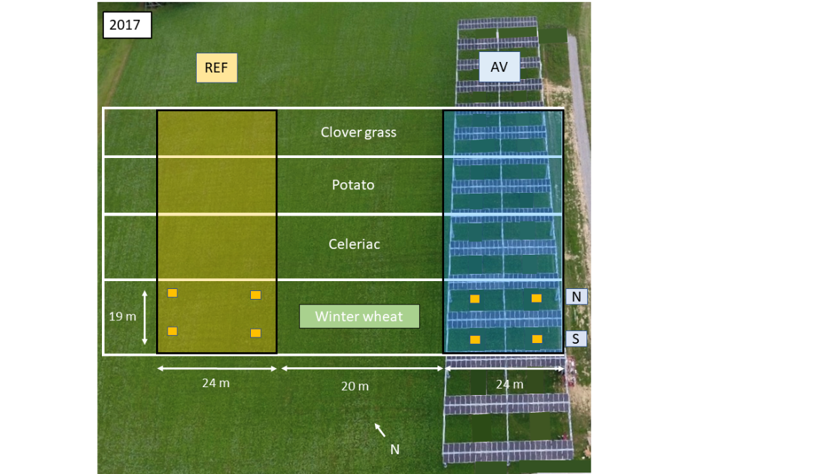
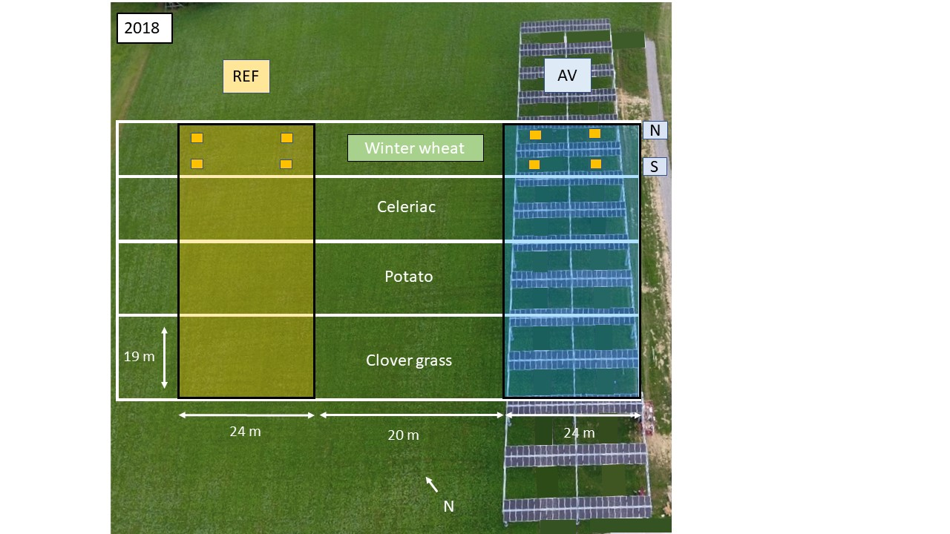
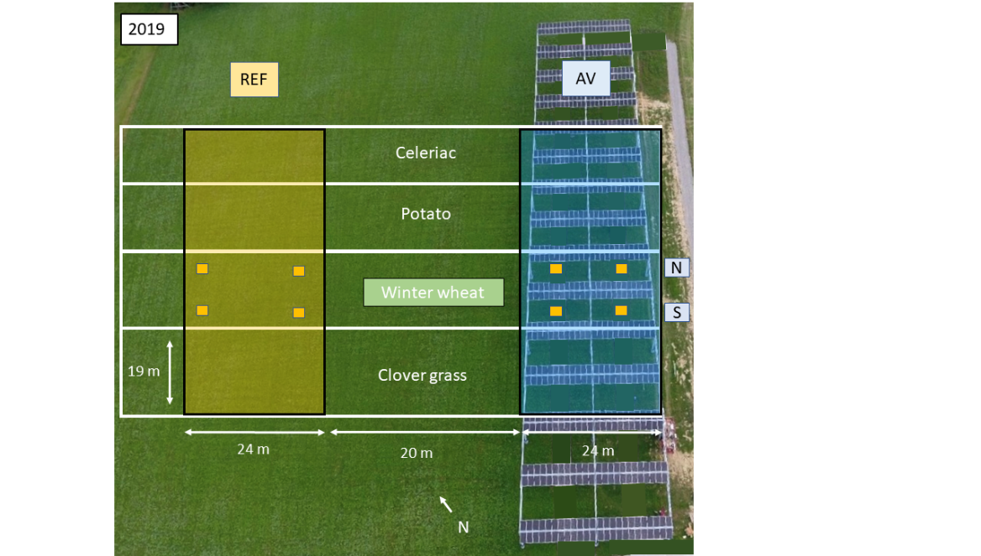
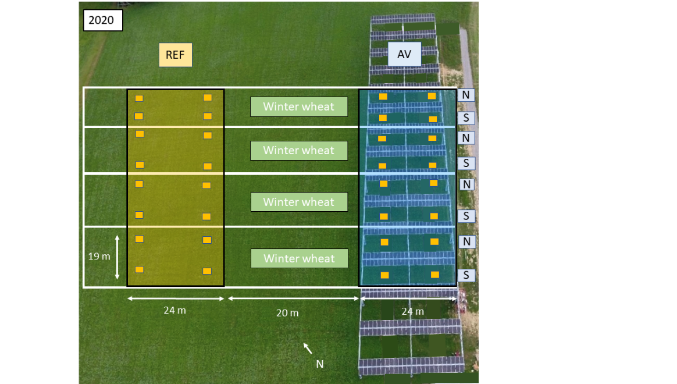
A)
B)
C)
D)
Fig. S1. Field trial design of the cropping seasons A) 2016/17, B) 2017/18, C) 2018/19 and D) 2019/20 with reference (REF) and agrivoltaic (AV) sites. Sampling plots of 1 m² are indicated by yellow boxes. N = northern sampling row, S = southern sampling row (source: modified after BayWa r.e.).
Table S1. Soil properties of the plots in an agrivoltaic system (AV) and on an adjacent reference site (REF) of the research site in Herdwangen-Schönach, November 2018.
Parameters | Unit | Depth | Ø AV | Ø REF
Sand | % | 0 – 30 cm | 44 | 40
Silt | % | 0 – 30 cm | 40 | 41
Clay | % | 0 – 30 cm | 16 | 19
Textural class | - |  | Sandy loam
pH | - | 0 – 30 cm | 5.7 | 5.5
Organic carbon | % | 0 – 30 cm | 0.9 | 1.0
Total nitrogen | % | 0 – 30 cm | 0.1 | 0.1
CAL-P | mg 100 g⁻¹ soil | 0 – 30 cm | 8.6 | 5.7
CAL-K | mg 100 g⁻¹ soil | 0 – 30 cm | 8.8 | 9.3
Mineral nitrogen | kg ha⁻¹ | 0 – 30 cm | 36.3 | 38.2
 |  | 30 – 60 cm | 12.5 | 15.4
 |  | 60 – 90 cm | 8.0 | 8.8

Table S2. Agronomic measures of winter wheat cultivation in the vegetation periods 2016/17, 2017/18, 2018/19 and 2019/20 of the agrivoltaic research site in Herdwangen-Schönach.

Agronomic measure | Date and application details
Sowing | Season 2016/17: October 22nd, 2016  Season 2017/18: October 25th, 2017  Season 2018/19: October 15th, 2018  Season 2019/20: October 20th, 2019
Density | 200 kg ha⁻¹ (+ 15 kg cover crop in 2019/20)
Fertilization | 10-15 m³ ha⁻¹ cattle slurry, 1-2 x per season
 | 20 l ha⁻¹ horn manure and silica each, 1-2 x per season
50 kg ha⁻¹ elemental sulfur (only in 2018/19)
Compost tea preparation: 20 l ha⁻¹ in 200 l water (only in 2017/18)
Field management | Comb harrowing, 1-3 x per season
Preceding crop | Season 2016/17: Clover grass (perennial)  Season 2017/18: Clover grass (annual)  Season 2018/19: potato  Season 2019/20: clover grass, winter wheat, potato, celeriac
Harvest | Season 2016/17: August 8th, 2017  Season 2017/18: July 31st, 2018  Season 2018/19: August 5th, 2019  Season 2019/20: August 3th, 2020

Table S3. Grain yield (t ha⁻¹) and isotopic carbon composition (δ¹³C, ‰; carbon-13 discrimination, CID, ‰) of winter wheat grains cultivated in an agrivoltaic system (AV) and on an unshaded adjacent reference site (REF) between 2016-2020 at Herdwangen-Schönach (Germany).
Trait | Treatment | Mean | Block | Pre-crop | Y x T | LSD 0.05
2016/17
δ¹³C (‰) | AV | -29.3 ± 0.03 | * | - | - | a
 | REF | -28.5 ± 0.03 |  |  |  | b
CID (‰) | AV | 21.9 ± 0.04 | * | - | - | a
 | REF | 21.1 ± 0.04 |  |  |  | b
Yield (t ha⁻¹) | AV | 4.6 ± 0.3 | ns | - | - | ns
 | REF | 5.7 ± 0.3 |  |  |  | ns
2017/18
δ¹³C (‰) | AV | -28.3 ± 0.1 | ns | - | - | a
 | REF | -27.3 ± 0.1 |  |  |  | b
CID (‰) | AV | 20.9 ± 0.06 | ns | - | - | a
 | REF | 19.9 ± 0.06 |  |  |  | b
Yield (t ha⁻¹) | AV | 4.7 ± 0.3 | ns | - | - | ns
 | REF | 4.6 ± 0.3 |  |  |  | ns
2018/19
δ¹³C (‰) | AV | -29.5 ± 0.1 | ns | - | - | a
 | REF | -28.9 ± 0.1 |  |  |  | b
CID (‰) | AV | 22.1 ± 0.13 | ns | - | - | a
 | REF | 21.6 ± 0.13 |  |  |  | b
Yield (t ha⁻¹) | AV | 4.9 ± 0.2 | ns | - | - | b
 | REF | 6.9 ± 0.2 |  |  |  | a
2019/20
δ¹³C (‰) | AV | -28.8 ± 0.1 | * | * | - | a
 | REF | -27.8 ± 0.1 |  |  |  | b
CID (‰) | AV | 21.4 ± 0.06 | * | * | - | a
 | REF | 20.3 ± 0.06 |  |  |  | b
Yield (t ha⁻¹) | AV | 4.3 ± 0.3 | ns | ns | - | ns
 | REF | 4.1 ± 0.3 |  |  |  | ns
2016-2020
δ¹³C (‰) | AV | -29.1 ± 0.1 | * | * | ** | a
 | REF | -28.1 ± 0.1 |  |  |  | b
CID (‰) | AV | 21.7 ± 0.06 | * | * | ** | a
 | REF | 20.7 ± 0.06 |  |  |  | b
Yield (t ha⁻¹) | AV | 4.7 ± 0.2 | ns | ns | * | ns
 | REF | 5.2 ± 0.2 |  |  |  | ns
*, ** Significant difference at 0.05 and 0.01 significance levels; ± refers to standard error. Different letters for LSD indicate significant differences between treatments. ns means not significantly different. Y x T means year*treatment effect

