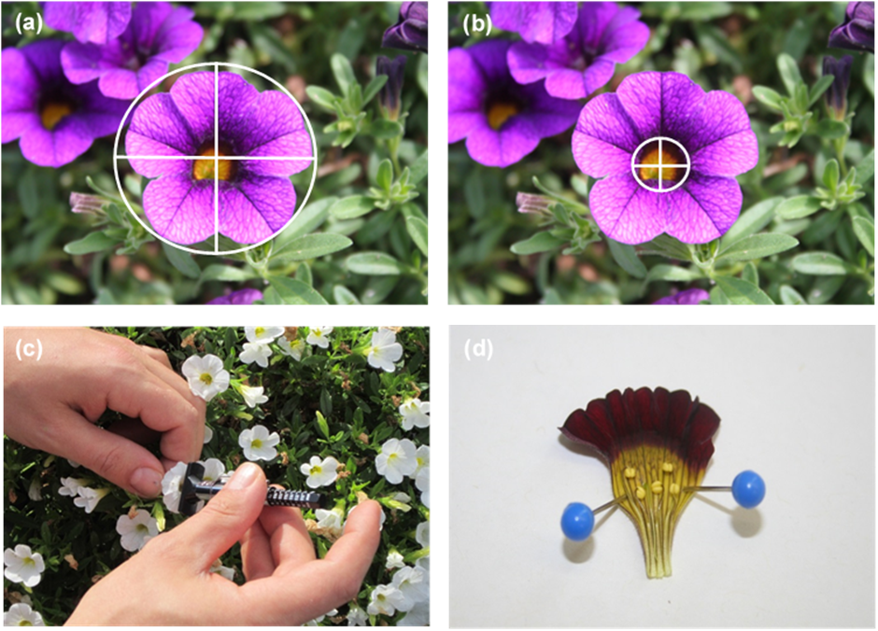
Fig. S1: The photos illustrate how the flower diameters horizontally and vertically (a), the corolla diameters horizontally and vertically (b) and the corolla depths were assessed (c). A halved Calibrachoa-flower is depicted in photo (d). The stamens were numbered one to five from the left to the right and the lengths measured with the help of a customary ruler. All photos were taken on June 2nd, 2017. Photos: Nils Westermann.

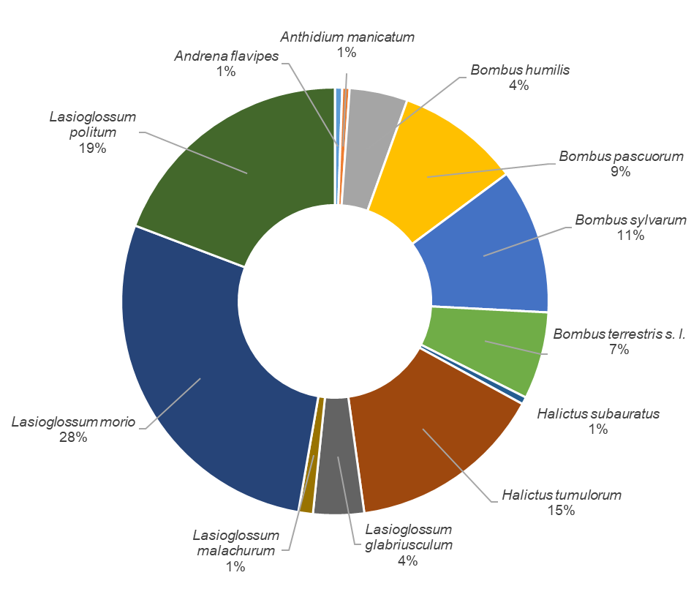
Fig. S2: Relative abundance of foraging wild bee species on the tested 20 Calibrachoa cultivars.

Table S1: Euclidean distances among the petal color loci of the 20 tested Calibrachoa cultivars and the center point (0/0). Distances < 0.1 hexagon unit are additionally marked in bold.

Table S2: Average floral morphometric parameters of the tested 20 Calibrachoa cultivars in the year 2017 in Heidelberg and Stuttgart (flower vertical and horizontal, corolla vertical and horizontal, corolla depth) or only in Heidelberg (length of the stamens).

Table S3. List of the 27 identified and verified compounds in the 20 tested Calibrachoa cultivars, whereby ‘+++’ = compound is present in high concentrations (peak area > 10.000.000 units), ‘++’ = compound is present in small concentrations (1.000.000 < peak area < 10.000.000 units), ‘+’ = compound is present in traces (peak area < 1.000.000 units) or ‘-‘ = compound is absent.
 | 1 | 2 | 3 | 4 | 5 | 6 | 7 | 8 | 9 | 10 | 11 | 12 | 13 | 14 | 15 | 16 | 17 | 18 | 19 | 20
2-methylbutanal | - | - | - | + | - | - | - | - | - | + | - | - | - | - | ++ | + | - | - | - | -
3-methylbutanal | - | + | - | ++ | - | + | - | + | - | + | - | + | + | - | ++ | ++ | + | + | - | ++
3-pentanone | ++ | - | - | - | - | - | - | - | - | - | ++ | - | - | - | - | - | - | + | ++ | -
(-)-α-pinene | ++ | ++ | + | - | +++ | +++ | +++ | +++ | ++ | - | +++ | +++ | ++ | +++ | - | +++ | +++ | ++ | +++ | +++
camphene | - | - | - | - | - | - | ++ | + | - | - | ++ | ++ | - | ++ | - | + | - | - | - | ++
hexanal | - | - | - | - | - | - | - | - | - | - | - | - | ++ | - | ++ | + | - | - | - | -
sabinene | - | ++ | - | - | +++ | +++ | ++ | +++ | +++ | - | - | +++ | +++ | +++ | - | +++ | +++ | - | ++ | +++
α-phellandrene | - | - | - | - | ++ | - | - | - | - | - | - | - | + | + | - | ++ | ++ | - | - | ++
β-myrcene | - | - | - | - | ++ | - | - | - | - | - | - | ++ | + | ++ | - | +++ | ++ | - | - | +++
α-terpinene | - | - | - | - | +++ | - | - | ++ | + | - | - | - | ++ | ++ | - | +++ | +++ | - | - | +++
D-limonene | - | - | - | - | ++ | - | ++ | - | - | - | - | ++ | - | ++ | - | ++ | ++ | - | - | ++
2-methyl-1-butanol | - | - | - | - | ++ | - | ++ | - | - | - | - | - | - | - | - | - | - | - | - | -
3-methyl-1-butanol | +++ | +++ | +++ | +++ | +++ | ++ | +++ | +++ | ++ | +++ | +++ | ++ | ++ | +++ | ++ | +++ | ++ | +++ | +++ | ++
eucalyptol | - | - | - | - | - | - | - | - | - | - | - | - | - | - | - | ++ | + | - | - | ++
γ-terpinene | - | - | - | - | +++ | ++ | - | ++ | ++ | - | - | - | ++ | +++ | - | +++ | +++ | - | - | +++
m-cymene | ++ | ++ | +++ | ++ | +++ | ++ | +++ | ++ | ++ | - | ++ | ++ | ++ | +++ | ++ | +++ | +++ | ++ | ++ | +++
p-cymene | +++ | ++ | +++ | +++ | +++ | +++ | +++ | +++ | ++ | - | ++ | ++ | +++ | +++ | ++ | +++ | +++ | +++ | +++ | +++
terpinolene | - | - | - | - | ++ | - | - | - | - | - | - | - | - | + | - | ++ | ++ | - | - | ++
octanal | - | - | - | + | + | ++ | - | - | - | - | - | - | ++ | - | - | - | - | - | - | -
3-methyl-1-pentanol | - | - | - | - | - | - | - | - | - | - | ++ | + | - | + | - | - | + | - | - | ++
1-hexanol | ++ | ++ | ++ | ++ | - | ++ | - | ++ | ++ | ++ | ++ | ++ | ++ | ++ | ++ | ++ | - | ++ | - | ++
(Z)-3-hexen-1-ol | ++ | - | ++ | ++ | - | - | - | - | ++ | ++ | - | - | - | - | - | - | - | + | - | -
(E)-2-hexen-1-ol | ++ | - | ++ | - | - | - | - | - | ++ | + | ++ | ++ | + | + | - | ++ | - | ++ | - | -
4-thujanol | - | - | - | - | - | - | - | - | - | - | - | - | - | - | - | ++ | ++ | - | - | ++
1-octanol | ++ | ++ | - | ++ | - | ++ | - | ++ | + | ++ | + | ++ | ++ | ++ | ++ | ++ | ++ | ++ | - | ++
terpinen-4-ol | - | - | - | - | +++ | - | - | - | - | - | - | - | + | ++ | - | +++ | ++ | - | - | ++
2-methylbutanoic acid | - | - | ++ | - | - | - | - | - | - | - | - | - | - | - | - | - | - | - | - | -

Table S4: ANOSIM R-value results based on the floral scent data and the seven different groups of bee-perceived petal colors in the Calibrachoa cultivars. For the calculation, the similarity index Bray-Curtis was used. R-values close to 1 represent highly different floral scents, whereas values close to 0 resemble in the floral scent.

Table S5: ANOSIM P-value results based on the floral scent data and the seven different groups of bee-perceived petal colors in the Calibrachoa cultivars. For the calculation, the similarity index Bray-Curtis was used. P-values < 0.05 differ significantly.

Table S6: SIMPER results based on the floral scent data and the seven different groups of bee-perceived petal colors in the Calibrachoa cultivars. For the calculation of the dissimilarities in percentage, the similarity index Bray Curtis was used. The higher the value, the more dissimilarities occur in regard to the floral scent between the two pairs.

