Supplementary data

Table S1: PCR conditions used for all PCR reactions during evaluation of specificity, using Dream Taq (Thermo Fisher Scientific).
Temperature [°C] | Time
95 | 2 min
95 | 30 sec
60 | 30 sec |  | x 35
72 | 1 min
72 | 5 min
4 | ∞

Table S2: Thermal cycling parameters used on the final qPCR runs according to the manufacturer’s protocol (Standard Bio Tools).
Step | Flex Six |  |  | 96.96 IFC
 | Temperature [°C] | Time | Temperature [°C] |  |  | Time
Thermal mixing | 25 | 30 min | 70 |  | 40 min
Thermal mixing | 70 | 60 min | 60 |  | 30 sec
Hot start | 95 | 1 min | 95 |  | 1 min
PCR, 30 cycles | 96 | 5 sec | 96 |  | 5 sec
PCR, 30 cycles | 60 | 20 sec | 60 |  | 20 sec
Melting curve | 60 | 3 sec | 60 |  | 3 sec
Melting curve | 60-95 | 1°C/3 sec | 60-95 |  |  | 1°C/3 sec

Supplementary figure

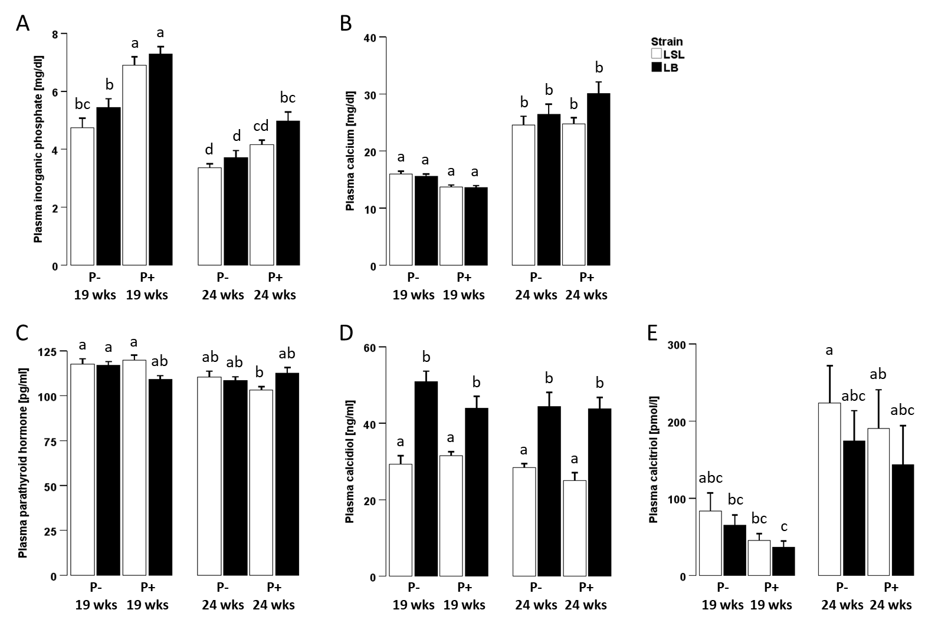

Figure S1: Plasma parameters for mineral homeostasis before and after onset of laying activity
Plasma levels of inorganic phosphate (A), total calcium (B), parathyroid hormone (C), calcidiol (D) and calcitriol (E) in laying hens before (19 weeks) and after (24 weeks) onset of lay fed with 1 g/kg (P+) or without (P-) supplemental alimentary phosphorus in two different laying hen strains (Lohmann LSL (LSL; white) or Lohmann Brown (LB; black)). Values are presented as arithmetic means ± standard error of mean. Data are already published in Qasir et al. 2025. Different superscripts indicate statistical differences between the experimental groups.

Supplementary reference

Qasir, Hiba; Reyer, Henry; Oster, Michael; Ponsuksili, Siriluck; Trakooljul, Nares; Sommerfeld, Vera et al. (2025): Effects of a transient lack of dietary mineral phosphorus on renal gene expression and plasma metabolites in two high-yielding laying hen strains. In: BMC genomics 26 (1), S. 129. DOI: 10.1186/s12864-025-11294-6.

