Journal: Ecological Applications
Title: Complementary effects of pollination and pest control services enable ecological intensification in macadamia orchards

Authors: Mina Anders¹, Catrin Westphal^{1,2}, Valerie M.G. Linden³, Sina Weier⁴, Peter J. Taylor⁴, Ingo Grass⁵

Affiliations:
- Functional Agrobiodiversity, Department of Crop Sciences, University of Göttingen, 37077 Göttingen, Lower Saxony, Germany
- Centre of Biodiversity and Sustainable Land Use (CBL), University of Göttingen, 37077 Göttingen, Lower Saxony, Germany
- School of Mathematical & Natural Sciences and Core Team Member of the Centre for Invasion Biology, University of Venda, Thohoyandou, 0950, Limpopo, South Africa
- Department of Zoology and Entomology, University of the Free State, Bloemfontein, 9301, Free State, South Africa
- Ecology of Tropical Agricultural Systems, University of Hohenheim, 70599 Stuttgart, Baden-Württemberg, Germany

1 Arthropod abundance

Statistical analysis
To analyze arthropod abundance in and under the trees, we used generalized linear models (glmmTMB) from the R package 'glmmTMB' (Brooks et al., 2017) in R (R Core Team, 2022). We compared the number of arthropods, Hemiptera and Hymenoptera with and without predator exclusion. For all three models we applied a square root transformation to the response to improve the distribution of residuals and a Poisson distribution was most appropriate in all cases. The biocontrol exclusion treatment was set as fixed effect, while the site ID and position in block were set as crossed random effects.

Results
We observed 5355 individual arthropods from 15 different orders (Table S2), of which the most abundant groups were Hymenoptera (43.8%, mainly Formicidae) and Hemiptera (42.2%, mainly Aphids). The biocontrol exclusion experiment had a significant positive effect on the overall arthropod abundance (Figure S1), which was increased on average by 66% in the exclusion cages (Table S3: model art). Interestingly, the number of Hemiptera more than doubled when predators were excluded, while the exclusion cages had no effect on Hymenoptera (Table S3 model hym).

2 Macadamia damage classification
For the macadamia quality classification, we first separated the immature from the mature nuts using the oil content of each kernel. By floating the kernels in a saline bath (1300 g salt on 20 L water) those that sank were regarded as immature.
Additionally, we identified three distinct types of insect damage on the kernels: "early stink bug damage," which occurs when stink bugs feed on young nuts, "late stink bug damage" results from stink bugs feeding on more mature nuts that have a higher oil content and finally "nut borer damage," caused by certain species of Tortricid moths. The remaining nuts were further classified into “fungi” (damage caused by fungus), shell marks, which were indefinite light or dark marks on the shell, germination, which means geminated seeds and sound kernel.
Throughout the macadamia growing seasons, mature nuts naturally fall to the ground between February and June. We conducted regular collections of nuts on a weekly or biweekly basis from each sampling unit. In total, we collected 7,013 dry nuts-in-shell (DNIS) weighing 36.14 kg. The collected nuts were manually de-husked and then stored in well-ventilated paper bags for a few days until they dried. After the drying process, we weighed the dry nuts-in-shell and cracked the shells to extract the kernels. The kernels were then weighed, examined, and classified using standardized protocols. This allowed us to identify major categories of unsound kernels, including immature kernels and kernels with insect damage. Other less common types of defective kernels include those that are moldy, germinating, dark, or exhibit shell marks or brown centers.

Tables
TABLE S1: Sample sizes of racemes
Nested exclusion treatment | Total exclusion | Pollinator exclusion | Predator exclusion | Open trees
n racemes with initial nuts | 707 | 434 | 491 | 172
n racemes with final nuts | 560 | 381 | 425 | 125

TABLE S2: Arthropod abundance
Order | Individuals
Hymenoptera | 2344
(of which Formicidae | 1900)
Hemiptera | 2260
(of which Aphidae | 1398)
Diptera | 252
Lepidoptera | 155
Araneae | 141
Coleoptera | 83
Thysanoptera | 48
Psocoptera | 33
Orthoptera | 12
Diplopoda | 4
Neuroptera | 4
Odonata | 3
Mantodea | 2
Blattodea | 1

TABLE S3: Arthropod abundance predicted with biocontrol exclusion
 | Estimate | SE | Z | P
Model art
Response: arthropod abundance (square root)
(Intercept) | 2.047 | 0.166 | 12.373 | <0.001
Biocontrol (exclusion) | 0.249 | 0.101 | 2.459 | 0.014
Model hem
Response: Hemiptera abundance (square root)
(Intercept) | 1.100 | 0.307 | 3.583 | <0.001
Biocontrol (exclusion) | 0.429 | 0.140 | 3.371 | <0.001
Model hym
Response: Hymenoptera abundance (square root)
(Intercept) | 1.513 | 0.207 | 7.294 | <0.001
Biocontrol (exclusion) | 0.133 | 0.135 | 0.985 | 0.325

Figures

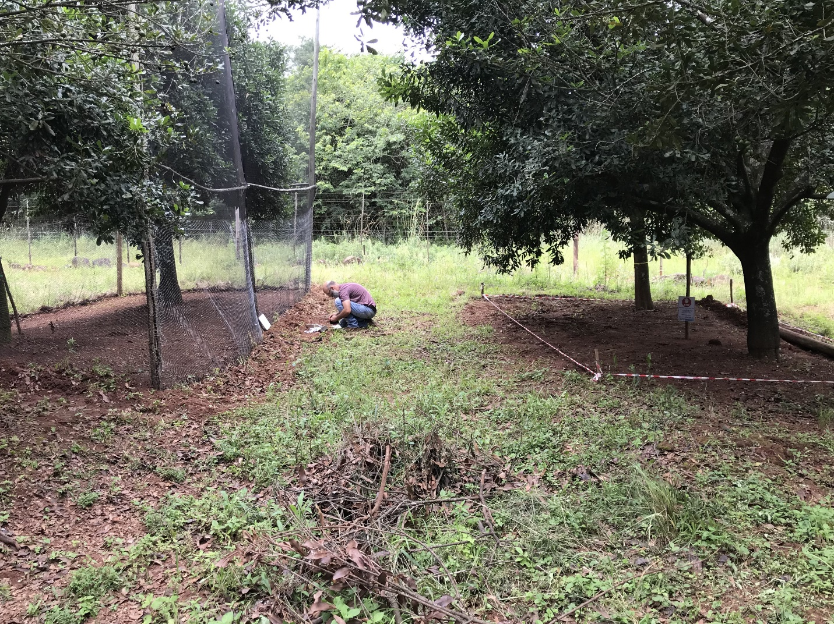
FIGURE S1: Experimental arrangement of the study trees. Two trees forming a sampling unit and are surrounded by a predator exclusion cage on the left, two control trees on the right. The trees are located at the edge to natural habitat (in the background). Photographs by Corrie Swanepoel

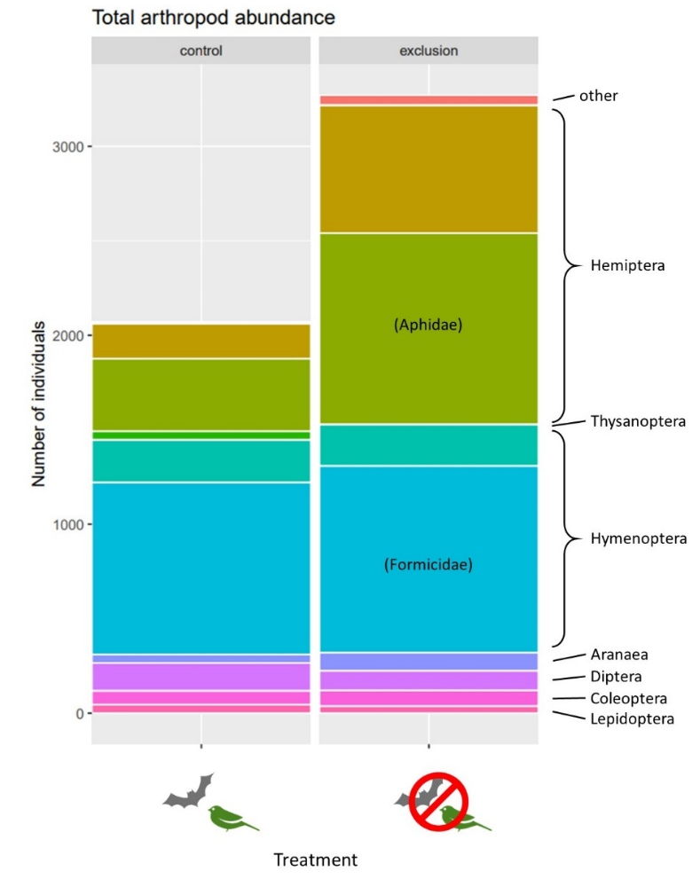
FIGURE S2: Total arthropod abundance per order with and without biocontrol exclusion.

References
Brooks, Mollie E., Kasper Kristensen, Koen J. van Benthem, Arni Magnusson, Casper W. Berg, Anders Nielsen, Hans J. Skaug, Martin Mächler, and Benjamin M. Bolker. 2017. ‘Modeling Zero-Inflated Count Data with glmmTMB’. bioRxiv, May, 132753. https://doi.org/10.1101/132753.
R Core Team. 2022. R: A Language and Environment for Statistical Computing. Vienna, Austria: R Foundation for Statistical Computing. https://www.R-project.org/.

