Appreciable genetic correlation between inbred lines and testcrosses facilitates breeding for resistance to Fusarium head blight in hybrid rye (Secale cereale L.)
Thomas Miedaner, Marvin Rose, Franziska Overbeck, Silvia Koch, Paul Gruner, Jakob Eifler
Correspondence: Thomas Miedaner, email: miedaner@uni-hohenheim.de

Supplemental Information
Table S1 Variance and covariance components with standard errors (SE) plus heritability estimates (H²) for Fusarium head blight severity of 60 inbred lines and their testcrosses with two testers for each of the heterotic pools Petkus and Carsten across the four corresponding environments (GCA=general combining ability, SCA=specific combining ability)
Parameter | Petkus |  | Carsten
 | Component | SE | Component | SE
Environment (E)¹ | 232.3 | 190.8 | 232.3 | 190.8
Inbred Lines:
Genotype (G) | 225.2 | 49.5 | 140.4 | 35.4
G×E | 148.3 | 18.5 | 178.8 | 21.9
H² | 0.84 |  | 0.74
Testcrosses:
Tester (T, GCA female) | 0.6 | 7.5 | 6.9 | 41.5
Line (L, GCA male) | 27.6 | 8.7 | 52.1 | 12.8
T×L (SCA) | 0.9 | 4.1 | 1.4 | 3.9
T×E | 16.2 | 11.3 | 83.2 | 49.9
L×E | 29.6 | 8.1 | 27.5 | 7.6
T×L×E | 62.0 | 7.9 | 56.4 | 7.2
H²_{GCA male} | 0.61 |  | 0.76
Covariance (Correlation):
G (Lines - GCA female) | 65.5 (0.83) | 17.0 | 60.1 (0.70) | 17.4
G×E (Lines - GCA female) | 15.7 (0.24) | 8.4 | 28.3 (0.40) | 9.0
¹N_{inbred lines} = N_{testcrosses}= 4
Note: All estimates were based on a bivariate mixed model defining a single environmental effect for both inbred lines and testcrosses, unrelated (diagonal variance structure) effects for testcross-specific components (tester, tester×line) and unstructured variance-covariance effects for the genotype (line per se = G, and GCA) and the genotype-environment interactions resulting in both variance and covariance (correlation) estimates. The residual-error variance was constrained to one due to the use of a two-stage analysis and fitting errors from the first stage via weights in the second stage.
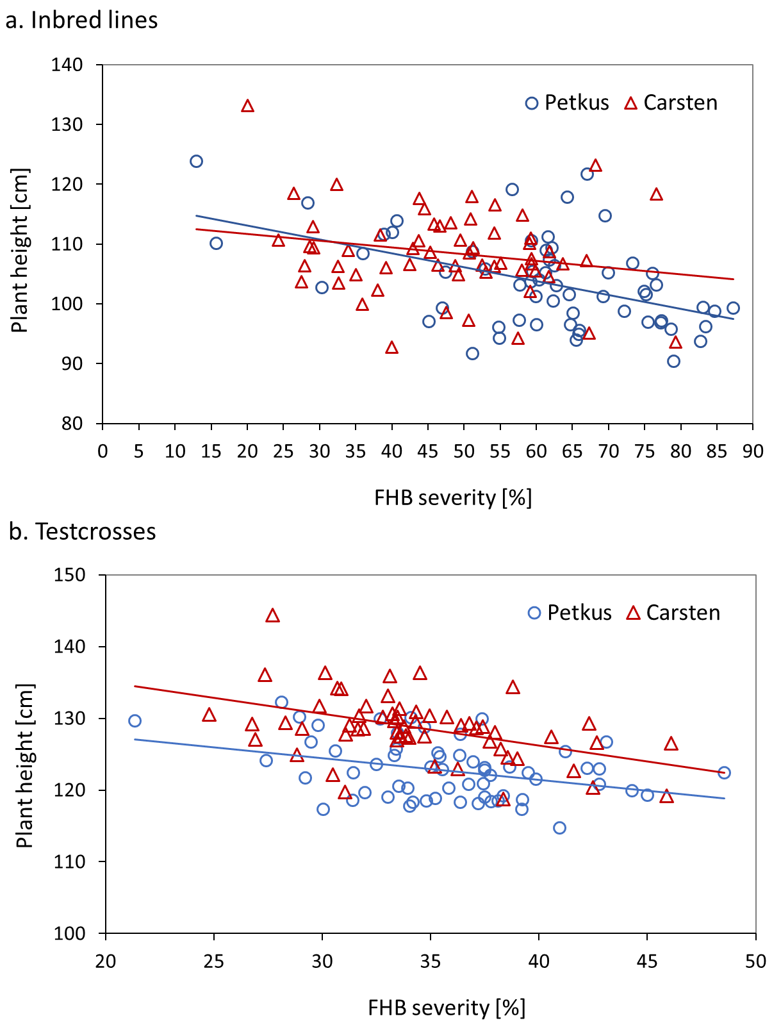

Fig. S1. Phenotypic correlations (Pearson) between Fusarium head blight severity (FHB, percentage of infected ear) with plant height for 60 inbred lines and the mean of their two testcrosses for the heterotic pools Petkus and Carsten across four (inbred lines) and six (testcrosses) environments; the lines mark the respective linear regression

