Structure formation in fruit preparations by fruit fermentates produced with exopolysaccharide-forming lactic acid bacteria
Silvan Festini, Dor Zipori, Marc Wallisch, Agnes Weiss, Sybille Neidhart, Herbert Schmidt, Mario Jekle
Supplementary Data
Figure S1 Flow curves (20 °C) of strawberry model fruit preparations containing different doses of lyophilized peach-, strawberry, carrot- or beetroot fermentate as the sole stabilizer. Fermentate variants used: Control = uninoculated control (fermentate blank, green); LB = Lv. brevis TMW 1.2112 fermentate (red); PP = P. parvulus LTH 1110 fermentate (blue)
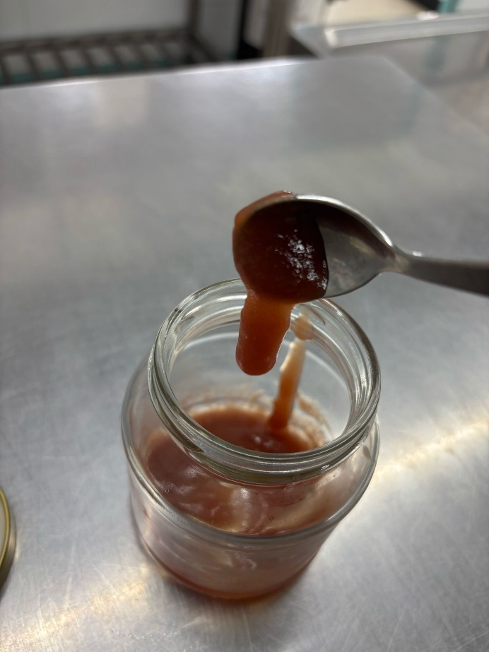
Figure S2 Photograph of a strawberry model fruit preparation made with 10.0% lyophilized Lv. brevis TMW 1.2112 peach fermentate as its sole stabilizer

